**CHAPTER 2**

**Effects of climate and temporal trends in forest songbird communities and abundance**

**along latitudinal and elevational gradients in the Appalachian Mountains**

**Introduction**

Wildlife populations naturally fluctuate over time from local to regional scales. However, consistent and widespread changes in abundance over long time periods are likely connected to a particular set of environmental or anthropogenic drivers, as may be the case for bird species breeding in the forests of eastern North America. Prevailing evidence suggests that forest songbird populations have been decreasing in abundance during the past century. These are passerine and near-passerine species that primarily breed in mature forest habitat, often nesting in trees and feeding on tree-associated insects. Past qualitative investigations note that numbers of certain breeding songbirds in eastern deciduous forests declined from the mid-1930s to the 1970s (Temple and Temple 1976, Ambuel and Temple 1982). Long-term data from annual, nationwide breeding bird surveys indicate that numerous bird species, many of which breed in forests (Robbins et al. 1989), have experienced decreases in their populations throughout the eastern United States from 1966 to 2019 (Sauer et al. 2020). Additionally, a recent quantitative study using data from multiple and independent monitoring networks demonstrated bird population losses across much of North America since 1970, including a negative change within the range of -15.6% to -19.2% in birds breeding in eastern forests, with 63.5% of those species in decline (Rosenberg et al. 2019). The U.S. Fish & Wildlife Service considers a statistically significant (*p* ≤ 0.1) population trend of -15% to -50% to be a “possible large decrease” and has identified 12 songbird species that breed in forests of eastern North America as “birds of conservation concern” (U.S. Fish & Wildlife Service 2021). Without targeted conservation action, there is concern that consistent declines in these and other bird populations will continue, with the potential for species to become endangered or even become extirpated (i.e., locally or regionally extinct) (Rosenberg et al. 2019).

In addition to multiple other factors, global climate change may contribute to declining populations of forest songbirds in eastern North America (Stephens et al. 2016, Rosenberg et al. 2019). Rising temperatures associated with climate change can negatively impact birds through direct and indirect interactions (Trautmann 2018). Warmer temperatures directly affect behavior (e.g., activity levels), thermoregulation, and incubation (Robbins 1981, Crick 2004), and temperature variability can affect energy expenditure, with consequences for reproductive output (Pendlebury et al. 2004). Temperature can also interact with landscape factors to lower songbird reproductive success (Cox et al. 2013*a*), and increasing temperatures may elevate rates of nest predation (Cox et al. 2013*b*). Furthermore, there is strong evidence that rising temperatures cause phenological mismatches between birds and vegetation budding dates and emergence of or peaks in their insect prey (Visser et al. 2006, Waite and Strickland 2006). In North America, the interval between spring green-up and arrival of migratory passerine species has increased, with certain species unable to keep pace (Mayor et al. 2017). These phenological changes can have fitness consequences; species populations may begin to decline if they fail to advance their egg-laying dates in response to increasing spring temperatures over time (Pearce-Higgins et al. 2015, Franks et al. 2018, Koleček et al. 2020). Changing precipitation patterns associated with climate change may also have direct and indirect negative effects on bird populations. Precipitation directly affects thermoregulation (Leech and Crick 2007), nest site selection (Martin 2001), and nest success and juvenile survival (Sherry et al. 2015). In the northeastern United States, precipitation was determined to influence bird species abundance (Duclos et al. 2019). Previous studies have also found lagged correlations between bird population trends and precipitation from the prior year (Pearce-Higgins et al. 2015). Overall, climate change appears to play a role in declining forest songbird populations in eastern North America through synergistic effects of changing temperatures and precipitation patterns.

However, climate change is unlikely to affect all forest songbird species in the same way. Negative impacts from warming temperatures may be most pronounced for cold-associated species (i.e., those that breed primarily in regions with colder temperatures, such as northern latitudes or high elevations), whereas climate generalist species (i.e., those that breed in regions with wide-ranging temperatures, without a strong association with particular latitudes or certain elevations) and warm-associated species (i.e., those that breed primarily in regions with warmer temperatures, such as southern latitudes or low elevations) may have a neutral or positive relationship with temperatures. For instance, studies often indicate that cold-associated species that occur at high elevations are particularly vulnerable to climate change (Rodenhouse et al. 2008, Siegel et al. 2014). In contrast, there is evidence of the distributions of warm-associated, low-elevation species expanding in regions where mean temperatures are rising (DeLuca and King 2017). Overall, climate change is expected to result in changes in the numbers of cold-associated species vs. climate generalist species vs. warm-associated species (i.e., climate-related guild richness) (Rodenhouse et al. 2008, Stralberg et al. 2009), with climate specialists and cold-associated species likely to be more negatively affected by higher temperatures than climate generalists or warm-associated species (Pearce-Higgins et al. 2015). In extreme circumstances (e.g., crossing unknown thresholds in tolerable climate conditions), certain bird species may become extirpated from sites or regions within their current range as temperatures continue to warm (Schwartz et al. 2006, Sekercioglu et al. 2008, Tayleur et al. 2016, Freeman et al. 2018).

Although it may be possible to broadly predict the effects of rising temperatures on forest songbird species based on their climate guild, there is less certainty concerning the additional effects of precipitation, particularly across latitudinal and elevational gradients. The importance of considering latitude and elevation in combination with climate change has been highlighted by multiple studies that track shifts in bird species distributions over time. Previous evidence suggests that species distributions are shifting northward in response to climate change (Thomas and Lennon 1999, Hitch and Leberg 2007, La Sorte and Thompson III 2007), and simultaneous latitudinal and elevational shifts have been documented and projected for the future (Pounds et al. 1999, Rodenhouse et al. 2008). For instance, populations of cold-associated, high-elevation species are likely to decline and warm-associated, low-elevation species may begin to expand into higher elevations in response to increasing temperatures (Forero-Medina et al. 2011, Tingley et al. 2012). However, elevational shifts are not always upward; along elevational gradients, climate change has caused heterogeneous range shifts, as rising temperature pushes species upslope while increased precipitation pulls them downslope (Tingley et al. 2012). A common assumption in these studies is that relationships with temperature and precipitation are static across latitudinal and elevational gradients. However, to accurately predict how climate change will affect forest songbirds in the future and to better inform conservation efforts, it is imperative to verify whether the influence of changing temperatures and precipitation amounts is mediated by latitude and elevation.

Looking forward, there is a critical need to address this research question, as climate change is affecting and will continue to affect the forest songbirds of eastern North America. Over the last several decades, this region has become warmer and wetter (Hayhoe et al. 2007, Huntington et al. 2009), though there is spatial variation in precipitation patterns. These trends of increasing temperatures and precipitation amounts are projected to continue in the future (Trenberth 2011, Rogers et al. 2016, Fernandez and Zegre 2019). To understand the role that temperature and precipitation have played in the ongoing declines in forest songbird populations in eastern North America and to predict the effects of future climate change, we need to evaluate historic temporal changes in abundance of individual species and in diversity of avian communities (Magurran et al. 2010, Rittenhouse et al. 2010) across both latitudinal and elevational gradients, such as provided by the Appalachian Mountains.

The Appalachian Mountains, which first formed ~480 million years ago during the Ordovician Period, are a dominant land feature of the eastern United States. They contain a range of elevations and primarily forested habitats, from temperate deciduous forests at lower latitudes/elevations to boreal coniferous forests at higher latitudes/elevations. The biota in this extensive region reflects that habitat diversity, with forest songbird communities comprising species from a plethora of families. With their elevational variability and latitudinal range, the Appalachian Mountains provide a twofold gradient over which to study avian communities and allow for the opportunity to simultaneously study multiple climate-related guilds. Within the Appalachian Mountains, there are cold-associated species that can be divided into 2 sub-categories: (1) northern species, which occur only in the northern and central latitudinal gradient of the mountain range (hereafter, Northern and Central Appalachians), and (2) trailing species, which have core populations in the northern latitudes and trailing-edge populations at higher elevations in the central and southern latitudes (i.e., Central and Southern Appalachians). Warm-associated species in the Appalachian Mountains comprise southern species which occur only in the Central and Southern Appalachians, and climate generalist species can be found throughout the entire mountain range.

**Purpose, objectives, and hypotheses**

The purpose of this collaborative study was to quantify potential differences in how forest songbird communities are affected by climate factors and to additionally explore additional temporal trends across latitudinal and elevational gradients within the Appalachian Mountains. My specific objectives were to apply interactions with both latitude and elevation in quantifying how temperature, precipitation, and other temporal factors influence climate-related guild richness and the abundance of specific focal species during the breeding season. To better capture the potential effects of climate factors and limit habitat variability, I focused exclusively on sampling points located in mature, primarily deciduous or mixed forests that had not been harvested in >60 years (similar to Duclos et al. [2019] but incorporating multiple study regions that spanned the Appalachian Mountains).

In this study, I tested the hypothesis that the effects of climate change on forest songbird communities during the breeding season are mediated by latitude and elevation. I predicted that relationships with climate factors and long-term temporal trends would vary by guild designation, latitude, and elevation. For example, I expected increasing temperatures to negatively affect northern and trailing species but positively affect southern species, and I expected increasing temperature variability (i.e., temperature extremes) and precipitation amounts to negatively affect all guilds. Furthermore, I conjectured that the magnitude of effect would increase near range limits, such that northern species would respond most strongly at low elevations in the Central Appalachians, trailing species would respond most strongly at low elevations in the Southern Appalachians, and southern species would respond most strongly at high elevations in the Central Appalachians. Taking a holistic approach, I assessed statistical significance and effect sizes of interactions with both latitude and elevation for overall species richness, 4 guild designations, and 16 focal forest songbird species (Table 1).

**METHODS**

**Study area**

Sampling points for this study were located throughout 3 study regions within the northern, central, and southern Appalachian Mountains (Figure 1). I used data from a total of 1733 sampling points (Figure 2), consisting of 373 sampling points in the Hubbard Brook Experimental Forest (HBEF) in the White Mountains of New Hampshire (~43.9° latitude), 1149 sampling points in the Monongahela National Forest (MNF) in the Allegheny Mountains of West Virginia (~38.5° latitude), and 211 sampling points in the Pisgah and Nantahala National Forests (PNF / NNF; collectively referred to as NCNF hereafter) in the Blue Ridge Mountains of North Carolina (~35.2° latitude). All sampling points used in this study were located in forest stands that had not been harvested in >60 years at the time of sampling, and distances between sampling points were at least 200 m.

Located in north-central New Hampshire, the HBEF was the source of data for the Northern Appalachians study region. The experimental forest was established in 1955 by the U.S. Forest Service and consists of a 3,160-ha bowl-shaped valley within the White Mountains National Forest. The HBEF lies in the New England physiographic province, specifically the Northern Appalachian and Atlantic Maritime Highlands ecoregion, and is characterized by sloping and steep terrain, ranging from 222–1015 m in elevation. The majority of the HBEF consists of second-growth, uneven-aged, and unmanaged northern hardwoods that grade into boreal forests at higher elevations (Holmes 2011). The forest has remained uncut since the early 1900s, but periodic severe weather events, such as ice storms, contribute to heterogeneity in forest structure (Rhoads et al. 2011). Average annual precipitation is ~140 cm, of which 25–33% is snow. Vegetation consists primarily of sugar maple (*Acer saccharum*), American beech (*Fagus grandifolia*), and yellow birch (*Betula alleghaniensis*), with white ash (*Fraxinus americana*) on lower and middle slopes and eastern hemlock (*Tsuga canadensis*) near stream drainages. At high elevations, red spruce (*Picea rubens*), balsam fir (*Abies balsamea*), and white birch (*Betula papyrifera* var. *cordifolia*) are common. The understory generally contains seedlings and saplings of the major tree species, as well as hobblebush (*Viburnum alnifolium*), striped (*Acer pensylvanicum*) and mountain maple (*A. spicatum*), and various ferns and forbs (Holmes 2011).

Located in east-central West Virginia, the MNF was the source of data for the Central Appalachians study region. The national forest was established in 1920 and encompasses 371,906 ha of public, federally owned land. It stretches across a latitudinal range of nearly 200 km and lies within 2 ecoregions / physiographic provinces, the Central Appalachians (Allegheny Mountains) and the Ridge and Valley. The eastern section, which overlaps the Ridge and Valley physiographic province, lies in the rain shadow of the Allegheny Mountains, so it receives significantly less precipitation (~75 cm per year) compared to the rest of the forest, which experiences 115–150 cm per year (Clarkson 1966). Elevation ranges 275–1480 m. The MNF hosts high regional tree diversity, with 4 major forest zones (mixed mesophytic, northern hardwoods, red spruce, and dry oaks) (McCay et al. 1997, DeMeo 1999). Mixed mesophytic forests are present at low elevations (<900 m), with northern red oak (*Quercus rubra*), sugar maple, hickory (*Carya* spp.), and tulip-poplar (*Liriodendron tulipifera*) as the dominant species (Madarish et al. 2002). Northern hardwoods, including sugar maple, American beech, and black cherry (*Prunus serotina*), dominate mid-elevations (Stephenson 1993). At the highest elevations (>1150 m), remnant boreal forest ecosystems consist of red spruce. Dry oaks are common in the Ridge and Valley area, consisting of white (*Quercus alba*), chestnut (*Q. prinus*), scarlet (*Q. coccinea*), and black (*Q. velutina*) oaks, as well as pines (*Pinus* spp.). Forest stands in the MNF were generally 70–100 years old at the start of the study period.

Located in western North Carolina, the NCNF (i.e., combined PNF and NNF) were the sources of data for the Southern Appalachians study region. The U.S. Forest Service established the PNF in 1911, and it comprises >20,200 ha of primarily hardwood forest, whereas the NNF was established in 1920 and covers ~214,950 ha in area. Both national forests have elevations ranging 360–1770 m and lie within the Blue Ridge ecoregion and physiographic province, with a mean annual precipitation of 152 cm. Vegetation in the NCNF consists of mature (i.e., >75 years since last logging) southern Appalachian hardwood forest dominated by oaks and other hardwood species, including yellow birch, black birch (*Betula lenta*), sugar maple, and American beech.

**Guild designations**

To assess climate relationships and temporal trends for overall species richness and guild richness, I used a specific subset of forest songbird species. Although a total of 153 bird species were detected across all surveys in all years from all 3 study regions, I limited the richness analyses to 40 species (see Appendix A for full list) in Order Passeriformes that were mature forest obligates with breeding ranges that overlapped at least 1 of the 3 study regions. I enacted these species restrictions for several reasons: (1) the bird count data were from avian point count surveys, which are primarily designed to detect passerines (i.e., songbirds); (2) this study focused on breeding birds rather than migrants; and (3) by concentrating on bird species with similar breeding habitat requirements or preferences, I sought to minimize differences in species responses due to forest habitat change, since the primary variables of interest were climate factors.

Climate-related guild designations for the 40 forest songbird species were assigned based on their ranges within the Appalachian Mountains and comprised 4 mutually exclusive categories (Appendix A): north, south, trailing, and general. Species in the north guild were only found in the Northern or Central Appalachians study regions, whereas species in the south guild were only found in the Southern or Central Appalachians study regions. Species in the trailing guild could be found in all 3 study regions in the Appalachian Mountains but had trailing-edge populations that were most abundant in the Northern Appalachians and at higher elevations in the Central or Southern Appalachians study regions. In contrast, species in the general guild were found throughout all 3 study regions in the Appalachian Mountains.

**Focal species**

To assess climate relationships and temporal trends for focal species belonging to each guild designation, I selected 16 forest songbird species commonly found within the Appalachian Mountains (Table 1). In addition to limiting the focal species by taxonomic order, breeding range, and primary breeding habitat as described above for the richness analyses, I considered only long-distance migrants to keep migration status consistent and selected at least 3 relatively abundant (i.e., >250 detections; Appendix A) species from the 3 taxonomic families (Parulidae, Turdidae, and Tyrannidae) with the most species meeting all the criteria. These selection decisions were made to ensure that models would run efficiently and to compare any potential differences between the 4 guilds within taxonomic families.

**Bird count data**

Avian point count survey data for the 3 study regions were collected in 1999–2002 and 2005–2019 at 373 HBEF sampling points, in 1993–2013 and 2017–2020 at 1149 MNF sampling points, and in 1997–2018 and 2020 at 211 NCNF sampling points. Avian point count surveys were not completed every year at every sampling point. The number of years of data associated with each sampling point ranged 1–19 years (mean = 17.5 ± 1.6 years) in the HBEF, 1–17 years (mean = 4.6 ± 3.9 years) in the MNF, and 8–23 years (mean = 17.6 ± 3.3 years) in the NCNF. Within a year that avian point count survey data were collected, the number of repeated visits (i.e., replicate surveys) ranged from 1–5 visits (mean = 3.0 ± 0.8 visits) in the HBEF and 1–4 visits (mean = 1.2 ± 0.4 visits) in the MNF; in the NCNF, only 1 avian point count survey was completed per year. I included all replicate surveys per sampling point per year in my data analyses, for a total of 29,610 replicate surveys across 15,494 site × year combinations.

Avian point count surveys were conducted from mid-May to early July (i.e., during the bird breeding season) and consisted of 10-minute stationary counts, during which a single observer recorded the species and number of all birds heard or seen. Up to 4 detection covariates were recorded for each survey: date, start time, wind code or wind speed, and sky code. For data standardization, any recorded wind speed measurements were converted to wind codes using the Beaufort wind scale. While date was recorded for all surveys, a subset of surveys was missing start times (55% of MNF data, 4% of NCNF data), wind codes or wind speeds (59% of MNF data, 7% of NCNF data), or sky codes (<1% of HBEF data, 60% of MNF data, 7% of NCNF data). However, all surveys began within 30 minutes of sunrise and continued until approximately 4 hours after sunrise, and no surveys were conducted on days with rain, heavy fog, or high wind speed, following the guidelines of Ralph et al. (1993).

The 10-minute point count survey was divided into 3 time intervals (i.e., within-survey replicates): 0:00–3:20, 3:21–6:40, and 6:41–10:00 minutes (HBEF); 0:00–3:00, 3:01–5:00, and 5:01–10:00 minutes (MNF); or 0:00–3:59, 4:00–5:59, and 6:00–10:00 minutes (NCNF). For each individual bird that was detected, observers recorded the corresponding time interval and distance band (≤50 m or >50 m). During point count surveys within the HBEF, each 3:20-minute interval was treated as a new sampling period (i.e., the presence of an individual bird would be recorded 3 separate times if the bird sang in all 3 time intervals), but observers indicated if a bird appeared for the first time or not during a time interval. Thus, I was able to convert all HBEF data to a removal sampling format prior to data analyses. During point count surveys within the MNF and NCNF, individual birds were only recorded the first time they were observed, following removal sampling methods. To limit detection variability due to distance, I restricted all data analyses to birds detected within 50 m.

**Environmental data**

The full set of site covariates included year of data collection, latitude, elevation, 4 focal climate variables, and 4 environmental variables that were included to control for their known effects (Table 2). Latitude corresponded to the location of the sampling point. Mean elevation within 50 m of each sampling point was calculated using Shuttle Radar Topography Mission digital elevation data, which had a resolution of ~20–25 m (Table 2). The focal climate variables consisted of mean breeding season (i.e., 15 May to 30 June) temperature during the year of data collection (hereafter mean temperature), standard deviation of mean breeding season temperature (hereafter SD temperature), and mean total breeding season precipitation during the year of data collection and during the previous year (hereafter current precipitation and previous precipitation, respectively). All climate data were calculated from PRISM Climate Group daily temperature and precipitation data (Daly et al. 2008) corresponding to 15 May through 30 June of each survey year. The 4 environmental variables consisted of aspect, topographic position index (TPI), dominant (i.e., occupying the greatest proportion of area within 50 m of the sampling point) forest type (deciduous, mixed, or coniferous), and proportion of any type of mature forest cover within 1 km of the sampling point. Mode aspect and mode TPI within 50 m of each sampling point were derived from Shuttle Radar Topography Mission digital elevation data. To determine the dominant forest type and proportion of forest cover, I used land cover data from the National Land Cover Database (NLCD), which has a resolution of 30 m and is available for the years 2001, 2004, 2006, 2008, 2011, 2013, 2016, and 2019. All calculations were made using land cover data from the closest year available (i.e., I used the 2001 NLCD data for surveys conducted in 2002 or earlier, 2004 NLCD data for surveys conducted in 2003 or 2004, 2006 NLCD data for surveys conducted in 2005–2007, 2008 NLCD data for surveys conducted in 2008 or 2009, 2011 NLCD data for surveys conducted in 2010–2012, 2013 NLCD data for surveys conducted in 2013 or 2014, 2016 NLCD data for surveys conducted in 2015–2017, and 2019 NLCD data for surveys conducted in 2018 or later). Note that the years 2005, 2007, and 2012 were equally close to 2004 vs. 2006, 2006 vs. 2008, and 2011 vs. 2013, respectively; I chose to use the 2006 NLCD data for both 2005 and 2007, and I chose to use the 2011 data for 2012 because it was when on-the-ground conditions were originally measured and ensured the most overall consistency.

**Data analysis**

*Determining overall species and guild richness from a hierarchical community model*

To calculate overall species richness and guild richness at each sampling point in each year sampled, I estimated the individual species occupancy of the 40 forest songbird species simultaneously in a hierarchical community model (see Appendix B for JAGS code) and then derived the corresponding sums for all species and each guild designation (Zipkin et al. 2010). The hierarchical community model facilitated a multi-species approach to estimating individual species occurrence probabilities (Dorazio and Royle 2005, Dorazio et al. 2006). Following the modeling framework of Zipkin et al. (2010), species-specific occurrence and detection processes within the hierarchical community model were related to one another through a community-level hierarchical component, which assumed that each of the species parameters were random effects, governed by “hyper-parameters” (i.e., drawn from a community-level distribution). Linking individual species occurrence probabilities through this community-level hierarchical component leads to improved precision of species-specific estimates (Kéry and Royle 2008, Zipkin et al. 2009).

Occurrence *Zs,y,sp* was defined as a binary variable in which *Zs,y,sp* = 1 if species *sp* occurs within 50 m of sampling point *s* in year *y*. The occurrence state was assumed to be the outcome of a Bernoulli random variable, denoted by:

*Zs,y,sp* ~ *Bernoulli*(*Ψs,y,sp*)

where *Ψs,y,sp*is the probability that species *sp* occurs at sampling point *s* in year *y*. I further used a logit link to model linear relationships between occurrence probability (*Ψs,y,sp*) and 6 site covariates, which consisted of latitude, elevation, aspect, TPI, dominant forest type, and proportion of forest. All continuous site covariates were centered and scaled prior to analysis.

Due to missing detection data and inconsistencies in time intervals of avian point count survey periods among the 3 study regions, I had to customize the species-specific detection model within the hierarchical community model. Given the observed data *Ys,y,r,sp*, where *r* is a within-survey replicate (i.e., time interval during the point count survey period) across all survey replicates (i.e., repeated visits to the sampling point during the sampling year), I defined the detection model for species *sp* at sampling point *s* in year *y* during replicate *r* as:

*Ys,y,r,sp* ~ *Bernoulli*(*ps,y,r,sp* × *Zs,y,sp*)

where *ps,y,r,sp* is the probability of detecting species *sp* at least once during the *r*th within-survey replicate at sampling point *s* in year *y*, given that species *sp* is present at sampling point *s* in year *y*. Note that the detection probability (*p*) was calculated in such a way as to handle uneven timing (ranging 2–5 minutes) among the within-survey replicates, which corresponded to the 3 time intervals during the avian point count survey period; I initially modeled detection probability of species *sp* at sampling point *s* in year *y* during replicate *r* for 1 minute (*p1*) and then I used an approach similar to the logistic exposure model (Shaffer 2004) to calculate the probability that an individual is detected at least once during the entire time interval *t* of the within-survey replicate *r* (e.g., 2, 3, or 5 minutes), using the following equation:

*ps,y,r,sp* = 1 – (1 – *p1s,y,r,sp*)*t*

I further used a logit link to model linear relationships between detection probability (*ps,y,r,sp*) and 4 detection covariates, which consisted of ordinal day (centered and scaled prior to analysis), time since sunrise (measured as decimal hours and centered and scaled prior to analysis), a dummy variable for wind (0 = wind codes of 0, 1, or 2; 1 = wind codes >2), and a dummy variable for sky (0 = sky codes of 0, 1, or 2; 1 = sky codes >2). I imputed study region-specific detection covariates for avian point count surveys that were lacking data on time, wind code, or sky code. I assumed that time since sunrise was a Gaussian random variable with region-specific prior mean and variance, and that the wind and sky dummy variables were Bernoulli random variables with region-specific probabilities of success. Imputation was informed by the observed data and accounted for uncertainty, with values drawn from a posterior distribution of each detection variable (Gelman et al. 2014).

The hierarchical community model yielded species-specific estimates of latent occupancy (*Zs,y,sp*) for species *sp* at each sampling point *s* in each year *y* based on observed data from replicate surveys. I then derived the overall species richness for each sampling point in each year by summing the occupancy of the 40 forest songbird species, as in the following equation:

Similarly, I derived guild-specific richness by summing the occupancy of the subset of forest songbird species that belonged to each guild designation.

I was able to integrate distinct detection processes and explicitly account for the effects of different sampling methods in each study region within the hierarchical community model by using a Bayesian framework, implemented with Markov chain Monte Carlo methods. For all community-level and species-specific parameters, I used prior distributions which were meant to provide little information; all gamma prior distributions, often used for variance parameters, had a shape parameter of 1 and rate parameter of 1, and all Gaussian prior distributions, such as for the community-level slope coefficients for each site covariate, had a mean of 0 and precision of either 0.1 or 1 (Appendix B). I fit the models in JAGS (Plummer 2003) using the “jagsUI” package (Kellner and Meredith 2021) in Program R (R Core Team 2022). I used the “jags” function to run 3 chains for the hierarchical community model with a burn-in of 2,500 iterations, thinning rate of 1 iteration, and iteration increment of 1,000, which resulted in 3,000 posterior draws and reasonable convergence (R̂ ≤ 1.1) (Gelman et al. 2014).

*Determining relationships with climate factors and temporal trends for overall species and guild richness*

After I derived detection-corrected overall species and guild richness from the hierarchical community model, I then incorporated those estimates into corresponding generalized linear mixed effects models, with overall species or guild richness as the response variable and incorporating the 4 climate variables as predictor variables. To propagate uncertainty from the original hierarchical community model results, I ran 3,000 iterations of the generalized linear mixed effects models for overall species richness and for each guild designation, cycling through the values from each of the 3,000 posterior draws. In result, the models yielded a posterior distribution of 3,000 for each slope coefficient, from which I derived the mean and 95% credible intervals. Thus, the estimated effects on overall species and guild richness were calculated as derived quantities (Kery and Royle 2016).

For each generalized linear mixed effects model, I assumed the number of species at each site in each year (i.e., overall species richness or guild richness) to be a Poisson random variable and used a log link to model relationships with controlling habitat factors and interactions between year, elevation, and mean temperature (used as an index for latitude). All continuous predictor variables were centered and scaled prior to analysis. The total number of slope coefficients was 25 (resulting in a ratio of ~620 sites to 1 slope coefficient; Bolker et al. 2008), corresponding to 9 single site covariates (year, latitude, elevation, mean temperature, SD temperature, current precipitation, previous precipitation, dominant forest type, and proportion of forest), 11 two-way interactions (latitude × year, latitude × elevation, latitude × mean temperature, latitude × SD temperature, latitude × current precipitation, latitude × previous precipitation, elevation × year, elevation × mean temperature, elevation × SD temperature, elevation × current precipitation, and elevation × previous precipitation), and 5 three-way interactions (latitude × elevation × year, latitude × elevation × mean temperature, latitude × elevation × SD temperature, latitude × elevation × current precipitation, latitude × elevation × previous precipitation). All of the generalized linear mixed effects models also incorporated a random site effect for log expected richness to account for repeated observations at each sampling point over the course of multiple years.

I fit all generalized linear mixed effects models using the “lme4” package (Bates et al. 2015) in Program R (R Core Team 2022). Specifically, I used the “glmer” function with family = “poisson”, optimizer = “bobyqa” (i.e., a specific optimizing function used by the model), and nAGQ = 0. The nAGQ is the number of points per axis for evaluating the adaptive Gauss-Hermite approximation to the log-likelihood. A value of zero uses a form of parameter estimation for generalized linear mixed effects models by optimizing the random effects and the fixed-effects coefficients in the penalized iteratively reweighted least squares step.

*Determining relationships with climate factors and temporal trends for individual focal species*

To quantify and compare how temperature, precipitation, and other temporal factors influenced specific focal species during the breeding season across latitudes and elevations, I estimated the abundance of 16 forest songbird species (Table 1) independently in stacked N-mixture models (Royle 2004) (see Appendix C for JAGS code). For the abundance model within the hierarchical stacked N-mixture model, I assumed that species count was a Poisson random variable and used a log link to model relationships with controlling habitat and topographical factors and interactions between year, elevation, and latitude. All continuous predictor variables were centered and scaled prior to analysis. The total number of slope coefficients was 27, corresponding to 11 single site covariates (year, latitude, elevation, mean temperature, SD temperature, current precipitation, previous precipitation, aspect, TPI, dominant forest type, and proportion of forest) and the same 11 two-way interactions and 5 three-way interactions as in the generalized linear mixed effects models. The stacked N-mixture models also incorporated a random site effect for log expected count to account for repeated observations at each sampling point over the course of multiple years.

Due to missing detection data and inconsistencies in time intervals of avian point count survey periods among the 3 study regions, I had to customize the detection model within the hierarchical stacked N-mixture model. I assumed that the observed count was a binomial random variable and modeled the adjusted probability of detection for the entire time interval of each within-survey replicate, using the same methods and equation as for the hierarchical community model. I further used a logit link to model linear relationships between detection probability and 4 detection covariates, which consisted of ordinal day (centered and scaled prior to analysis), time since sunrise (measured as decimal hours and centered and scaled prior to analysis), a dummy variable for wind (0 = wind codes of 0, 1, or 2; 1 = wind codes >2), and a dummy variable for sky (0 = sky codes of 0, 1, or 2; 1 = sky codes >2). I used the same methods as for the hierarchical community model to impute study region-specific detection covariates for avian point count surveys that were lacking data on time, wind code, or sky code.

The stacked N-mixture models were constructed in a Bayesian framework, implemented with Markov chain Monte Carlo methods. For all model parameters, I initially used prior distributions which were meant to provide little information; gamma prior distributions had shape and rate parameters of 0.01 or 0.1, and Gaussian prior distributions had a mean of 0 and precision of 0.01 or 0.1 (Appendix C). For two species (blackpoll warbler and yellow-bellied flycatcher) with relatively low abundance and restricted ranges, I used Gaussian prior distributions had a mean of 0 and precision of 1. I fit the models in JAGS (Plummer 2003) using the “jagsUI” package (Kellner and Meredith 2021) in Program R (R Core Team 2022). I used the “autojags” function to run 3 chains for each model with a burn-in of 2,000–137,000 iterations (Appendix D), thinning rate of 3 iterations, and iteration increment of 3,000–30,000; models iteratively ran until reasonable convergence (R̂ ≤ 1.1) was achieved (Gelman et al. 2014), resulting in 3,000–30,000 posterior draws.

*Determining significance of interactions*

For all of the guild richness models and focal species abundance models, relationships with individual variables were considered significant when the 95% credible intervals of their slope coefficient values did not overlap zero (Table 3, Figures 3–4). Similarly, interactions with latitude and elevation (Tables 4–5, Figures 3–4) were considered significant when the 95% credible intervals of their effective slope coefficient values did not overlap zero (Tables 6–7). I defined an effective slope coefficient as the effect of a 1-unit change in 1 predictor variable given specific levels of the 2 interacting variables (i.e., northern vs. central vs. southern latitudes and low vs. mid vs. high elevations).

**RESULTS**

**Variation in effects of temperature across latitudinal and elevational gradients**

Overall species richness, north guild richness, south guild richness, trailing guild richness, general guild richness, and each of the 16 focal forest songbird species had an average of ~4.9 effective slope coefficient values (range: 1–9) that were significant for mean temperature at various levels of latitude and elevation, with the direction and/or magnitude of the effects of mean temperature depending on latitude and elevation (Table 6, Figure 5). As predicted, 1 of the 3 northern species (Swainson’s thrush), trailing guild richness, and 3 of the 6 trailing species (Blackburnian warbler, black-throated green warbler, and black-throated blue warbler) responded negatively to increasing mean temperature across most of the Appalachian Mountains, and south guild richness and 2 of the 3 southern species (hooded warbler and worm-eating warbler) tended to respond positively, particularly in the Central Appalachians. General guild richness also had an overall positive relationship with mean temperature. However, contrary to expectations, I found a positive effect of mean temperature on north guild richness at low to mid elevations and on 2 of the 3 northern species (blackpoll warbler and yellow-bellied flycatcher), and I found a negative effect of mean temperature on south guild richness and 2 of the 3 southern species (hooded warbler and Acadian flycatcher) at low elevations in the Southern Appalachians. After determining the regions with the highest magnitude effects for each guild and focal forest songbird species, I was mostly correct in my original predictions regarding range limits. North guild richness and 1 of the 3 northern species (Swainson’s thrush) responded most strongly at low elevations in the Central Appalachians; trailing guild richness and 5 of the 6 trailing species (Blackburnian warbler, black-throated green warbler, black-throated blue warbler, Canada warbler, and least flycatcher) responded most strongly at either low or high elevations in the Southern Appalachians; and south guild richness responded most strongly at high elevations in the Central Appalachians. Interestingly, all 3 southern species (hooded warbler, worm-eating warbler, and Acadian flycatcher), general guild richness, and 3 of the 4 climate generalist species (American redstart, ovenbird, and wood thrush) had the highest magnitude responses at either low or high elevations in the Southern Appalachians, similar to trailing guild richness and most of the trailing species. Furthermore, the steepest negative effects for south guild richness, 2 of the southern species (hooded warbler and Acadian flycatcher), trailing guild richness, 3 of the 6 trailing species (Blackburnian warbler, black-throated blue warbler, and least flycatcher), general guild richness, and all 4 climate generalist species (American redstart, northern parula, ovenbird, and wood thrush) occurred at low elevations in the Southern Appalachians.

Overall species richness, north guild richness, south guild richness, trailing guild richness, general guild richness, and 13 of the 16 focal forest songbird species had an average of ~4.3 effective slope coefficient values (range: 1–8) that were significant for SD temperature at various levels of latitude and elevation, with the direction and/or magnitude of the effects of SD temperature depending on latitude and elevation (Table 6, Figure 5). As predicted, SD temperature had a negative effect on north guild richness, all 3 northern species (blackpoll warbler, Swainson’s thrush, and yellow-bellied flycatcher), 1 of the 3 southern species (Acadian flycatcher), trailing guild richness, and 4 of the 6 trailing species (Blackburnian warbler, black-throated green warbler, black-throated blue warbler, and Canada warbler). Contrary to expectations, south guild richness and 1 of the 3 southern species (worm-eating warbler) had positive relationships with SD temperature in the Central Appalachians, and general guild richness and 1 of the 4 climate generalist species (ovenbird) responded positively to SD temperature across most of the Appalachian Mountains. After determining the regions with the highest magnitude effects for each guild and focal forest songbird species, I was again mostly correct in my original predictions regarding range limits. North guild richness and 1 of the 3 northern species (Swainson’s thrush) responded most strongly at low elevations in the Central Appalachians; trailing guild richness and 2 of the 6 trailing species (Blackburnian warbler and black-throated blue warbler) responded most strongly at low elevations in the Southern Appalachians; and south guild richness responded most strongly at high elevations in the Central Appalachians. Furthermore, the steepest negative effects for overall species richness, 3 of the climate-related guilds, and 7 of the focal forest songbird species (all 3 northern species: blackpoll warbler, Swainson’s thrush, and yellow-bellied flycatcher; 3 of the 6 trailing species: Blackburnian warbler, black-throated blue warbler, and Canada warbler; and 1 of the 4 climate generalist species: American redstart) occurred at low elevations.

**Variation in effects of precipitation across latitudinal and elevational gradients**

Overall species richness, north guild richness, south guild richness, trailing guild richness, general guild richness, and 13 the 16 focal forest songbird species had an average of ~3.7 effective slope coefficient values (range: 0–8) that were significant for current precipitation at various levels of latitude and elevation, with the direction and/or magnitude of the effects of current precipitation depending on latitude and elevation (Table 7). As predicted, north guild richness, 1 of the 3 northern species (Swainson’s thrush), south guild richness, all 3 southern species (hooded warbler, worm-eating warbler, and Acadian flycatcher), and 2 of the 4 climate generalist species (ovenbird and wood thrush) had negative relationships with current precipitation. However, contrary to expectations, current precipitation positively affected trailing guild richness and 4 of the 6 trailing species (Blackburnian warbler, black-throated green warbler, black-throated blue warbler, and Canada warbler). After determining the regions with the highest magnitude effects for each guild and focal forest songbird species, I was partially correct in my original predictions regarding range limits. North guild richness and 1 of the 3 northern species (Swainson’s thrush) responded most strongly at low elevations in the Central Appalachians, and south guild richness and 1 of the 3 southern species (hooded warbler) responded most strongly at high elevations in the Central Appalachians. In contrast, trailing guild richness responded most strongly in the Northern Appalachians, and trailing species tended to respond most strongly at high elevations. Specifically, current precipitation exhibited the highest magnitude effects on black-throated blue warbler abundance at high elevations in the Northern Appalachians, on Blackburnian warbler and veery abundance at high elevations in the Central Appalachians, and on black-throated green warbler abundance at high elevations in the Southern Appalachians. The steepest negative effects for overall species richness, 3 of the 4 climate-related guilds, and 5 of the focal forest songbird species (Swainson’s thrush, hooded warbler, worm-eating warbler, veery, and ovenbird) occurred in the Central Appalachians.

Overall species richness, north guild richness, south guild richness, trailing guild richness, general guild richness, and 15 of the 16 focal forest songbird species had an average of ~4.0 effective slope coefficient values (range: 0–8) that were significant for previous precipitation at various levels of latitude and elevation, with the direction and/or magnitude of the effects of previous precipitation depending on latitude and elevation (Table 7). Unlike my original prediction, previous precipitation had a mixed effect on overall species richness and guild richness, although all 3 southern species (hooded warbler, worm-eating warbler, and Acadian flycatcher), 2 of the 6 trailing species (black-throated green warbler and veery), and 2 of the 4 climate generalist species (ovenbird and wood thrush) tended to respond negatively as predicted. North guild richness had a positive relationship with previous precipitation at high elevations, south guild richness had a negative relationship at high elevations and a positive relationship at low to mid elevations in the Southern Appalachians, and trailing guild richness had a positive relationship in the Northern and Central Appalachians. After determining the regions with the highest magnitude effects for each guild and focal forest songbird species, the results did not generally support my original predictions regarding range limits. Although 4 of the 6 trailing species (Blackburnian warbler, black-throated blue warbler, veery, and least flycatcher) did respond most strongly to previous precipitation at low elevations in the Southern Appalachians, the strongest response for both north and trailing guild richness was at high elevations in the Northern Appalachians and for south guild richness was at low elevations in the Southern Appalachians. Furthermore, the steepest negative effects for overall species richness, 2 of the 4 climate-related guilds, and 4 of the focal forest songbird species (hooded warbler, black-throated green warbler, ovenbird, and wood thrush) occurred at high elevations in the Southern Appalachians.

**Variation in temporal trends across latitudinal and elevational gradients**

Temporal trends in overall species richness, north guild richness, south guild richness, trailing guild richness, general guild richness, and 15 the 16 focal forest songbird species varied among latitudes and elevations, with differences among the 4 guild designations (Table 7). Across most of the Appalachian Mountains, trailing guild richness, 4 of the 6 trailing species (Blackburnian warbler, black-throated green warbler, black-throated blue warbler, and veery), and 1 of the 4 climate generalist species (ovenbird) increased over time. For both north and south guild richness, temporal trends tended to be negative in the northern portion of their ranges (Northern and Central Appalachians, respectively) and positive in the southern portion of the ranges (Central and Southern Appalachians, respectively). Trailing guild richness and 4 of the 6 trailing species (Blackburnian warbler, black-throated green warbler, black-throated blue warbler, and veery) had the strongest temporal trends at low elevations in the Southern Appalachians, and all 3 southern species (hooded warbler, worm-eating warbler, and Acadian flycatcher) decreased the most in abundance over time at high elevations in the Central Appalachians. Otherwise, the regions with the strongest and most negative temporal trends varied among and within guilds, with low consistency in patterns.

**Discussion**

This study quantified the effects of climate factors on forest songbird communities and species abundance during the breeding season across latitudinal and elevational gradients within the Appalachian Mountains. I also investigated concurrent long-term temporal trends beyond climate change and determined how they were mediated by latitude and elevation. Model results supported the hypothesis that climate effects on forest songbird communities during the breeding season are mediated by latitude and elevation. My prediction that relationships with climate factors and long-term temporal trends would vary by climate-related guild designation, latitude, and elevation was supported. The 4 guilds showed distinct trends that varied among latitudinal regions and along elevational gradients within the Appalachian Mountains (Figure 5). Because temperatures are expected to rise and precipitation patterns will be altered in the future due to climate change (Trenberth 2011, Rogers et al. 2016, Fernandez and Zegre 2019), it is critical to incorporate this new understanding of dynamic relationships with climate factors across latitudinal and elevational gradients to improve region-specific predictions of how climate change will affect cold-associated, warm-associated, and climate generalist species. In addition, variation in temporal trends among guild designations, latitudes, and elevations indicates the potential need for additional research and conservation efforts for certain climate-related guilds in specific regions.

I had originally predicted that warming temperatures would negatively affect northern and trailing species but positively affect southern species, but my results only partially support that prediction. Broadly, temperature influenced guild richness and focal forest songbird species as expected, but there were certain exceptions due to changes in the relationship with temperature along latitudinal and elevational gradients. For example, north guild richness only exhibited the expected relationship at high elevations; at low elevations in both the Northern and Central Appalachians, the effect of mean temperature was positive. Similarly, mean temperature negatively affected south guild richness at low to mid elevations in the Southern Appalachians. These relationships are perhaps indicative of northern species shifting from higher elevations in more southerly latitudes to lower elevations at more northerly latitudes and southern species shifting from lower elevations in more southerly latitudes to higher elevations or higher latitudes, due to warming temperatures.

I had also predicted that the highest magnitude effects would be experienced near range limits, such as low elevations in the Central Appalachians for northern species, low elevations in the Southern Appalachians for trailing species, and high elevations in the Central Appalachians for southern species. This prediction was consistently supported by the guild richness results and the majority of the focal species results, particularly for temperature effects. In addition, general guild richness tended to have the strongest responses at high elevations in the Central and Southern Appalachians, which could be considered the peripheries of their range along an elevational gradient.

The findings from my study build upon the previous literature focused on climate change and forest songbirds in various portions of the Appalachian Mountains. Duclos et al. (2019) explored direct and indirect effects of climate on bird abundance along elevational gradients in the Northern Appalachians, with an overlap in 7 of the focal forest songbird species from my study. They found that climate exerts direct influences on bird abundance, as well as indirect influences mediated by vegetation composition and structure (Duclos et al. 2019). Although there were differences in methodology and metrics, climate relationships with abundance of 4 focal species were consistent with my results (e.g., positive direct effect of precipitation on yellow-bellied flycatcher and black-throated green warbler, negative indirect effect of temperature on Swainson’s thrush, positive indirect effect of temperature and negative direct effect of precipitation on ovenbird). DeLuca and King (2017) also focused on forest songbirds in the Northern Appalachians, noting both upslope and downslope shifts in elevational boundaries. In agreement with my study results that show decreasing abundance in certain focal forest songbird species at lower elevations in the Northern Appalachians in response to warming temperatures, DeLuca and King (2017) documented upward movement of the upper elevational boundary of black-throated blue warblers over time and overall upslope shifts in occurrence for black-throated blue warblers, ovenbirds, American redstarts, Canada warblers, and blackburnian warblers. Their study corroborated the importance of elevational gradients when considering the impacts of climate change, as did a climate mitigation review article focusing on the Southern Appalachians (Conroy et al. 2011). The authors of the latter paper predicted that both latitudinal and elevational gradients might mediate the influence of climate, such that birds at lower elevations near the edge of their southern range would be especially sensitive to climate drivers, which is what my study showed for both northern and trailing species.

Overall species richness exhibited a strong positive response to rising temperatures at low elevations throughout the Appalachian Mountains and within the Southern Appalachians, with mixed responses to increases in temperature variability and precipitation. Therefore, at a broad scale, climate change could potentially result in a slight increase in net overall species richness at sites across the Appalachian Mountains. However, results from this study underscore the importance of climate-related guild designation, with models indicating that the 4 guilds in the Appalachian Mountains would respond differently to climate change across the entire region (Figure 5). When applying the guild-level results in considerations of the potential effects of climate change, northern species and trailing species seem to be most at risk. Based on the modeled responses to temperature, trailing guild richness should decline in much of the Appalachian Mountains as temperatures warm, and both north and trailing guild richness and northern species abundance is likely to decline as temperatures become more variable. Increasing precipitation amounts may lead to further declines in north guild richness, but it may benefit trailing guild richness and trailing species, as precipitation generally had a positive effect on them. Other studies have also concluded that northern and high-elevation species are most at risk from warming temperatures (Rodenhouse et al. 2008). In contrast, general guild richness is most likely to respond positively to climate change. Increasing mean temperature and temperature variability both had a positive effect on general guild richness across most of the Appalachian Mountains, whereas increasing precipitation had mixed impacts.

In addition, the strength of this study is being able to determine specific regions (based on latitude and elevation) within the Appalachian Mountains where declines in overall species and guild richness and focal species abundance are mostly likely to occur in response to climate change (Figure 5). Assuming relationships with climate factors remain stationary through time and that future climate conditions do not surpass unknown biological thresholds in tolerance, I would expect the cumulative effects of warming temperatures and increasing temperature variability to result in the steepest decreases in southern species, trailing species, and climate generalist species at low elevations in the Southern Appalachians. Species occurring at low elevations in the Northern and Central Appalachians may also be vulnerable to increasing temperature variability. The effects of increasing precipitation were more variable and therefore less predictable.

Just as with relationships with climate factors, temporal trends in guild richness and focal species abundance were mediated by primarily latitude and elevation, although the direction of changes over time seemed primarily correlated with latitude (Table 7). For example, overall species richness decreased over time in the Southern Appalachians, northern species decreased over time in the Northern Appalachians, and southern species decreased over time in the Central Appalachians. Although there did not appear to be any discernible prevailing regional pattern in decreasing or increasing richness over time, other studies and datasets suggest similar temporal trends in the abundance of the 16 focal forest songbird species and have documented regional variation in those trends along latitudinal gradients. For example, my results regarding temporal trends in the 3 northern species align with those of a study that used data from 1993–2003 from the White Mountains of New Hampshire (King et al. 2008). As another example, Wilson et al. (2011) used North American Breeding Bird Survey data from 1982–2007 and detected a difference in percent change in mean abundance per year in the Atlantic Northern Forest Bird Conservation Region (which contains the HBEF study region) vs. the Northern Appalachian Mountains Bird Conservation Region (which contains the MNF study region) vs. the Southern Appalachian Mountains Bird Conservation Region (which contains the NCNF study region). In those regions, mean abundance of American redstarts tended to be declining, which was also reflected in my study results. When compared to regional temporal trends in the abundance of the 16 focal forest songbird species from 1993–2019 North American Breeding Bird Survey data (Ziolkowski et al. 2022) and 2007–2021 eBird trends data (Fink et al. 2022), which both aggregated their data across larger spatial regions, my results were in general agreement. Disparities in individual species trends over time were likely due to differences in spatial scales, since North American Breeding Bird Survey data were summarized by bird conservation regions and states, whereas my data reflected patterns in focal forest songbird species abundance at my 3 specific study regions within the Appalachian Mountains.

Indeed, it is important to note that my findings were extrapolated from protected, federally owned forests that have a history of minimal timber harvest within the past 60 years. Although I accounted for topographical factors, forest type, and proportion of mature forest in the surrounding landscape in my models, the results regarding temporal trends may not accurately represent the status of forest songbirds breeding on privately owned properties that involve large-scale or high-intensity timber harvest operations. Future research could investigate whether long-term trends in guild richness and species abundance along latitudinal and elevational gradients in the Appalachian Mountains vary across ownership types (i.e., private vs. public), disturbance regimes (e.g., timber harvest, prescribed fire), and/or forest habitat quality metrics. In contrast to temporal trends, the ecological relationships with climate factors at the various latitudes and elevations examined in my study are more likely to be broadly applicable to the mature forested landscapes that dominate the Appalachian Mountains region.

**Conclusions**

Here, I establish that the influence of temperature and precipitation on guild richness and abundance of forest songbirds breeding in the Appalachian Mountains is mediated by latitude and elevation. The results of this study are valuable for understanding historical effects of changing climate factors and improving predictions of future climate change impacts on forest songbirds in the Appalachian Mountains by verifying and delineating the dynamic nature of the relationships with temperature and precipitation across latitudinal and elevational gradients. They will also help to inform forest songbird conservation efforts in the Appalachian Mountains because they quantify the regional effects of temperature and precipitation on climate-related guilds and forest songbird species and identify specific latitudes and elevations at which they are at the highest risk from climate change and other temporal factors. Based on my models, climate mitigation strategies for forest songbirds in the Appalachian Mountains are most needed for cold-associated species and for low elevations in the Southern Appalachians.

**Acknowledgments**

This research was supported by the National Science Foundation Graduate Research Fellowship under Grant No. DGE-1102689, as well as by funding from the West Virginia Cooperative Fish and Wildlife Research Unit, West Virginia University (WVU), WVU Ruby Distinguished Doctoral Fellowship, WVU Outstanding Merit Fellowship for Continuing Doctoral Students, and the following research grants: Explorers Club Washington Group Exploration and Field Research Grant, WVU Stitzel Graduate Student Support Fund Award, and Association for Environmental Health and Sciences Foundation’s Dr. David F. Ludwig Memorial Student Travel Scholarship. I thank Spencer Crawford, Davey Walters, and Marco Messina for their hard work collecting the 2019–2020 Monongahela National Forest data as field technicians; Blayne Ott and Cassidy Rausch for assisting with data entry; and Cathy Johnson, Kyle Crafts, Andy Moore, Shane Jones, Joe Foster, Melissa Thomas-Van Gundy, Keith Krantz, Rich Rogers, Danny Bennett, and Brian Kain for facilitating access to Monongahela National Forest sampling points and providing field housing. I thank my project collaborators --- Scott Sillett, Matthew Ayres, Mike Hallworth, Catherine Johnson, Bob Cooper, Richard Chandler, and Sheryl Bryan --- for offering input during the project development stage and for facilitating access to or directly providing much of the bird data. Additional thanks to Donna Ray for helping to track down the data from the Pisgah and Nantahala National Forests. Finally, I appreciate the valuable contributions of all the field technicians who collected data from the Hubbard Brook Experimental Forest, Pisgah National Forest, and Nantahala National Forest.

**Literature Cited**

Ambuel, B., and S. A. Temple. 1982. Songbird populations in southern Wisconsin forests: 1954 and 1979. Journal of Field Ornithology 53:149–158.

Bates, D., M. Mächler, B. M. Bolker, and S. C. Walker. 2015. Fitting linear mixed-effects models using lme4. Journal of Statistical Software 67:1–48.

Bolker, B. M., M. E. Brooks, C. J. Clark, S. W. Geange, J. R. Poulsen, M. H. H. Stevens, and J. S. S. White. 2009. Generalized linear mixed models: A practical guide for ecology and evolution. Trends in Ecology and Evolution 24:127–135.

Clarkson, R. 1966. The vascular flora of the Monongahela national forest, West Virginia. Castanea 31:1–119.

Conroy, M. J., M. C. Runge, J. D. Nichols, K. W. Stodola, and R. J. Cooper. 2011. Conservation in the face of climate change: The roles of alternative models, monitoring, and adaptation in confronting and reducing uncertainty. Biological Conservation 144:1204–1213.

Cox, W. A., F. R. Thompson III, and J. L. Reidy. 2013b. The effects of temperature on nest predation by mammals, birds, and snakes. The Auk 130:784–790.

Cox, W. A., F. R. Thompson, J. L. Reidy, and J. Faaborg. 2013a. Temperature can interact with landscape factors to affect songbird productivity. Global Change Biology 19:1064–1074.

Crick, H. Q. P. 2004. The impact of climate change on birds. Ibis 146:48–56.

Daly, C., M. Halbleib, J. I. Smith, W. P. Gibson, M. K. Doggett, G. H. Taylor, J. Curtis, and P. P. Pasteris. 2008. Physiographically sensitive mapping of climatological temperature and precipitation across the conterminous United States. International Journal of Climatology 28:2031–2064.

DeLuca, W. V., and D. I. King. 2017. Montane birds shift downslope despite recent warming in the northern Appalachian Mountains. Journal of Ornithology 158:493–505.

DeMeo, T. E. 1999. Forest songbird abundance and viability at multiple scales on the Monongahela National Forest, West Virginia. Ph.D. Dissertation, West Virginia University, Morgantown, West Virginia, USA.

Dorazio, R. M., and J. A. Royle. 2005. Estimating size and composition of biological communities by modeling the occurrence of species. Journal of the American Statistical Association 100:389–398.

Dorazio, R. M., J. A. Royle, B. Söderström, and A. Glimskär. 2006. Estimating species richness and accumulation by modeling species occurrence and detectability. Ecology 9658:12–15.

Duclos, T. R., W. V. DeLuca, and D. I. King. 2019. Direct and indirect effects of climate on bird abundance along elevation gradients in the Northern Appalachian mountains. Diversity and Distributions 25:1670–1683.

Fernandez, R., and N. Zegre. 2019. Seasonal changes in water and energy balances over the Appalachian region and beyond throughout the twenty-first century. Journal of Applied Meteorology and Climatology 58:1079–1102.

Fink, D., T. Auer, A. Johnston, M. Strimas-Mackey, S. Ligocki, O. Robinson, W. Hochachka, L. Jaromczyk, A. Rodewald, C. Wood, I. Davies, and A. Spencer. 2022. eBird Status and Trends, Data Version: 2021; Released: 2022. Cornell Lab of Ornithology, Ithaca, New York.

Forero-Medina, G., J. Terborgh, S. J. Socolar, and S. L. Pimm. 2011. Elevational ranges of birds on a tropical montane gradient lag behind warming temperatures. PLoS ONE 6:e28535.

Franks, S. E., J. W. Pearce‐Higgins, S. Atkinson, J. R. Bell, M. S. Botham, T. M. Brereton, R. Harrington, and D. I. Leech. 2018. The sensitivity of breeding songbirds to changes in seasonal timing is linked to population change but cannot be directly attributed to the effects of trophic asynchrony on productivity. Global Change Biology 24:957–971.

Freeman, B. G., M. N. Scholer, V. Ruiz-Gutierrez, and J. W. Fitzpatrick. 2018. Climate change causes upslope shifts and mountaintop extirpations in a tropical bird community. Proceedings of the National Academy of Sciences of the United States of America 115:11982–11987.

Gelman, A., J. B. Carlin, H. S. Stern, and D. B. Rubin. 2014. Bayesian data analysis. Third edition. CRC Press, Boca Raton, Florida, USA.

Hayhoe, K., C. P. Wake, T. G. Huntington, L. Luo, M. D. Schwartz, J. Sheffield, E. Wood, B. Anderson, J. Bradbury, A. DeGaetano, T. J. Troy, and D. Wolfe. 2007. Past and future changes in climate and hydrological indicators in the US Northeast. Climate Dynamics 28:381–407.

Hitch, A. T., and P. L. Leberg. 2007. Breeding distributions of North American bird species moving north as a result of climate change. Conservation Biology 21:534–539.

Holmes, R. T. 2011. Avian population and community processes in forest ecosystems: Long-term research in the Hubbard Brook Experimental Forest. Forest Ecology and Management 262:20–32.

Huntington, T. G. H. G., A. D. R. D. Richardson, K. J. M. J. McGuire, and K. H. Hayhoe. 2009. Climate and hydrological changes in the northeastern United States: recent trends and implications for forested and aquatic ecosystems. Canadian Journal of Forest Research 39: 199–212.

Jin, S., C. Homer, L. Yang, P. Danielson, J. Dewitz, C. Li, Z. Zhu, G. Xian, and D. Howard. 2019. Overall methodology design for the United States National Land Cover Database 2016 products. Remote Sensing 11:2971.

Kellner, K., and M. Meredith. 2021. Package “jagsUI.” <http://mcmc-jags.sourceforge.net>.

Kéry, M., and J. A. Royle. 2008. Hierarchical Bayes estimation of species richness and occupancy in spatially replicated surveys. Journal of Applied Ecology 45:589–598.

Kéry, M., and J. A. Royle. 2016. Applied hierarchical modeling in ecology. Academic Press, Boston, Massachusetts, USA.

King, D. I., J. D. Lambert, J. P. Buonaccorsi, and L. S. Prout. 2008. Avian population trends in the vulnerable montane forests of the Northern Appalachians, USA. Biodiversity and Conservation 17:2691–2700.

Koleček, J., P. Adamík, and J. Reif. 2020. Shifts in migration phenology under climate change: temperature vs. abundance effects in birds. Climatic Change 159:177–194.

La Sorte, F. A., and F. R. Thompson III. 2007. Poleward shifts in winter ranges of North American birds. Ecology 88:1803–1812.

Leech, D. I., and H. Q. P. Crick. 2007. Influence of climate change on the abundance, distribution, and phenology of woodland bird species in temperate regions. Ibis 149:128–145.

Madarish, D. M., Rodrigue, J. L., and M. B. Adams. 2002. Vascular flora and macroscopic fauna on the Fernow Experimental Forest. General Technical Report NE-291. USDA Forest Service Northeast Research Station, Newtown Square, Pennsylvania, USA.

Magurran, A. E., S. R. Baillie, S. T. Buckland, J. M. Dick, D. A. Elston, E. M. Scott, R. I. Smith, P. J. Somerfield, and A. D. Watt. 2010. Long-term datasets in biodiversity research and monitoring: Assessing change in ecological communities through time. Trends in Ecology & Evolution 25:574–582.

Martin, T. E. 2001. Abiotic vs. biotic influences on habitat selection of coexisting species: Climate change impacts? Ecology 82:175–188.

Mayor, S. J., R. P. Guralnick, M. W. Tingley, J. Otegui, J. C. Withey, S. C. Elmendorf, M. E. Andrew, S. Leyk, I. S. Pearse, and D. C. Schneider. 2017. Increasing phenological asynchrony between spring green-up and arrival of migratory birds. Scientific Reports 7:1902.

McCay, D. H., M. D. Abrams, and T. E. DeMeo. 1997. Gradient analysis of secondary forests of eastern West Virginia. Journal of the Torrey Botanical Society 124:160–173.

Pearce-Higgins, J. W., N. Ockendon, D. J. Baker, J. Carr, E. C. White, R. E. A. Almond, T. Amano, E. Bertram, R. B. Bradbury, C. Bradley, S. H. M. Butchart, N. Doswald, W. Foden, D. J. C. Gill, R. E. Green, W. J. Sutherland, and E. V. J. Tanner. 2015. Geographical variation in species’ population responses to changes in temperature and precipitation. Proceedings of the Royal Society B: Biological Sciences 282:20151561.

Pearce-Higgins, J. W., S. M. Eglington, B. Martay, and D. E. Chamberlain. 2015. Drivers of climate change impacts on bird communities. Journal of Animal Ecology 84:943–954.

Pendlebury, C. J., M. G. MacLeod, and D. M. Bryant. 2004. Variation in temperature increases the cost of living in birds. Journal of Experimental Biology 207:2065–2070.

Plummer, M. 2003. JAGS: A program for analysis of Bayesian graphical models using Gibbs sampling. In K Hornik, F Leisch, A Zeileis (eds.). Proceedings of the 3rd International Workshop on Distributed Statistical Computing (DSC 2003). Vienna, Austria.

Pounds, J. A., M. P. L. Fogden, and J. H. Campbell. 1999. Biological response to climate change on a tropical mountain. Nature 398:611–615.

R Core Team. 2022. R: A language and environment for statistical computing. R Foundation for Statistical Computing, Vienna, Austria. https://www.R-project.org/.

Ralph, C.J., S. Droege, J.R. Sauer. 1993. Managing and monitoring birds using point counts: standards and applications. General Technical Report PSW-GTR-149. U.S. Forest Service, Albany, California, USA.

Rhoads, A. G., S. P. Hamburg, T. J. Fahey, T. G. Siccama, E. N. Hane, J. Battles, C. Cogbill, J. Randall, and G. Wilson. 2011. Effects of an intense ice storm on the structure of a northern hardwood forest. Canadian Journal of Forest Research 32:1763–1775.

Rittenhouse, C. D., A. M. Pidgeon, T. P. Albright, P. D. Culbert, M. K. Clayton, C. H. Flather, C. Huang, J. G. Masek, S. I. Stewart, and V. C. Radeloff. 2010. Conservation of forest birds: Evidence of a shifting baseline in community structure. PLoS ONE 5:e11938.

Robbins, C. 1981. Bird activity levels related to weather. Studies in Avian Biology 6:301–310.

Robbins, C. S., J. R. Sauer, R. S. Greenberg, and S. Droege. 1989. Population declines in North American birds that migrate to the neotropics. Proceedings of the National Academy of Sciences 86:7658–7662.

Rodenhouse, N. L., S. N. Matthews, K. P. McFarland, J. D. Lambert, L. R. Iverson, A. Prasad, T. S. Sillett, and R. T. Holmes. 2008. Potential effects of climate change on birds of the Northeast. Mitigation and Adaptation Strategies for Global Change 13:517–540.

Rogers, B. M., P. Jantz, S. J. Goetz, and D. M. Theobald. 2016. Vulnerability of tree species to climate change in the Appalachian Landscape Conservation Cooperative. Pages 212–233 in Climate Change in Wildlands: Pioneering Approaches to Science and Management. Island Press, Washington, DC.

Rosenberg, K. V, A. M. Dokter, P. J. Blancher, J. R. Sauer, A. C. Smith, P. A. Smith, J. C. Stanton, A. Panjabi, L. Helft, M. Parr, and P. P. Marra. 2019. Decline of the North American avifauna. Science 366:120–124.

Royle, J. A. 2004. N-mixture models for estimating population size from spatially replicated counts. Biometrics 60:108–115.

Sauer, J. R., W. A. Link, and J. E. Hines. 2020. The North American breeding bird survey, analysis results 1966–2019. US Geological Survey data release 10:P96A7675.

Schwartz, M. W., L. R. Iverson, A. M. Prasad, S. N. Matthews, and R. J. O’Connor. 2006. Predicting extinctions as a result of climate change. Ecology 87:1611–1615.

Sekercioglu, C. H., S. H. Schneider, J. P. Fay, and S. R. Loarie. 2008. Climate change, elevational range shifts, and bird extinctions. Conservation Biology 22:140–150.

Shaffer, T. 2004. Unified approach to analyzing nest success. The Auk 121:526–540.

Sherry, T. W., S. Wilson, S. Hunter, and R. T. Holmes. 2015. Impacts of nest predators and weather on reproductive success and population limitation in a long-distance migratory songbird. Journal of Avian Biology 46:559–569.

Siegel, R. B., P. Pyle, J. H. Thorne, A. J. Holguin, C. A. Howell, S. Stock, and M. W. Tingley. 2014. Vulnerability of birds to climate change in California’s Sierra Nevada. Avian Conservation & Ecology 9:7.

Stephens, P. A., L. R. Mason, R. E. Green, R. D. Gregory, J. R. Sauer, J. Alison, A. Aunins, L. Brotons, S. H. M. Butchart, T. Campedelli, T. Chodkiewicz, P. Chylarecki, O. Crowe, J. Elts, V. Escandell, R. P. B. Foppen, H. Heldbjerg, S. Herrando, M. Husby, F. Jiguet, A. Lehikoinen, Å. Lindström, D. G. Noble, J. Y. Paquet, J. Reif, T. Sattler, T. Szép, N. Teufelbauer, S. Trautmann, A. J. Van Strien, C. A. M. Van Turnhout, P. Vorisek, and S. G. Willis. 2016. Consistent response of bird populations to climate change on two continents. Science 352:84–87.

Stephenson, S. L. 1993. Upland forests of West Virginia. McClain Printing Co, Parsons, West Virginia, USA.

Stralberg, D., D. Jongsomjit, C. A. Howell, M. A. Snyder, J. D. Alexander, J. A. Wiens, and T. L. Root. 2009. Re-shuffling of species with climate disruption: a no-analog future for California birds? PLoS ONE 4:e6825.

Tayleur, C. M., V. Devictor, P. Gaüzère, N. Jonzén, H. G. Smith, and Å. Lindström. 2016. Regional variation in climate change winners and losers highlights the rapid loss of cold-dwelling species. Diversity and Distributions 22:468–480.

Temple, S. A., and B. L. Temple. 1976. Avian population trends in central New York State, 1935-1972. Bird-Banding 47:238.

Thomas, C. D., and J. J. Lennon. 1999. Birds extend their ranges northwards. Nature 399:213.

Tingley, M. W., M. S. Koo, C. Moritz, A. C. Rush, and S. R. Beissinger. 2012. The push and pull of climate change causes heterogeneous shifts in avian elevational ranges. Global Change Biology 18:3279–3290.

Trautmann, S. 2018. Climate change impacts on bird species. Pages 217–234 in Bird Species. Springer, Cham.

Trenberth, K. E. 2011. Changes in precipitation with climate change. Climate Research 47:123–138.

U.S. Fish & Wildlife Service. 2021. Birds of conservation concern 2021. United States Department of the Interior, U.S. Fish & Wildlife Service, Migratory Birds, Falls Church, Virginia, USA. <http://www.fws.gov/birds/management/>.

managed-species/birds-of-conservation-concern.php

Visser, M. E., L. J. M. Holleman, and P. Gienapp. 2006. Shifts in caterpillar biomass phenology due to climate change and its impact on the breeding biology of an insectivorous bird. Oecologia 147:164–172.

Waite, T. A., and D. Strickland. 2006. Climate change and the demographic demise of a hoarding bird living on the edge. Proceedings of the Royal Society B: Biological Sciences 273:2809–2813.

Wilson, S., S. L. Ladeau, A. P. Tøttrup, and P. P. Marra. 2011. Range-wide effects of breeding-and nonbreeding-season climate on the abundance of a Neotropical migrant songbird. Ecology 92:1789–1798.

Ziolkowski Jr., D. J., M. Lutmerding, V. I. Aponte, and M-A. R. Hudson. 2022. North American Breeding Bird Survey Dataset 1966 - 2021: U.S. Geological Survey data release.

Zipkin, E. F., A. Dewan, and J. Andrew Royle. 2009. Impacts of forest fragmentation on species richness: A hierarchical approach to community modelling. Journal of Applied Ecology 46:815–822.

Zipkin, E. F., J. Andrew Royle, D. K. Dawson, and S. Bates. 2010. Multi-species occurrence models to evaluate the effects of conservation and management actions. Biological Conservation 143:479–484.

**Tables**

Table 1. List of the common name, scientific name, 4-letter species code, taxonomic family, and climate-related guild designation of the 16 forest songbird species used in the focal species analyses. Climate-related guild designations for the 40 forest songbird species were assigned based on their ranges within the Appalachian Mountains and comprised 4 mutually exclusive categories (Appendix A): north (only found in the Northern or Central Appalachians study regions), south (only found in the Southern or Central Appalachians study regions), trailing (found in all 3 study regions in the Appalachian Mountains but with trailing-edge populations that are limited to higher elevations in the Central or Southern Appalachians study regions), and general (found throughout all 3 study regions in the Appalachian Mountains). An asterisk following the common name indicates a species of regional conservation concern (i.e., listed as an Appalachian Mountains Joint Venture Priority Species or North American Bird Conservation Initiative’s Watch List species).

|  |  |  |  |  |  |  |
| --- | --- | --- | --- | --- | --- | --- |
| **Common Name** | **Scientific Name** | **Code** | **Family** | **Guild** | | |
| Blackpoll warbler* | *Setophaga striata* | BLPW | Parulidae | | north |
| Swainson's thrush | *Catharus ustulatus* | SWTH | Turdidae | | north |
| Yellow-bellied flycatcher* | *Empidonax flaviventris* | YBFL | Tyrannidae | | north |
| Acadian flycatcher* | *Empidonax virescens* | ACFL | Tyrannidae | | south |
| Hooded warbler* | *Setophaga citrina* | HOWA | Parulidae | | south |
| Worm-eating warbler* | *Helmitheros vermivorum* | WEWA | Parulidae | | south |
| Blackburnian warbler* | *Setophaga fusca* | BLBW | Parulidae | | trailing |
| Black-throated blue warbler | *Setophaga caerulescens* | BTBW | Parulidae | | trailing |
| Black-throated green warbler | *Setophaga virens* | BTNW | Parulidae | | trailing |
| Canada warbler* | *Cardellina canadensis* | CAWA | Parulidae | | trailing |
| Least flycatcher | *Empidonax minimus* | LEFL | Tyrannidae | | trailing |
| Veery | *Catharus fuscescens* | VEER | Turdidae | | trailing |
| American redstart | *Setophaga ruticilla* | AMRE | Parulidae | | general |
| Northern parula* | *Setophaga americana* | NOPA | Parulidae | | general |
| Ovenbird | *Seiurus aurocapilla* | OVEN | Parulidae | | general |
| Wood thrush* | *Hylocichla mustelina* | WOTH | Turdidae | | general |

Table 2. List of temporal (N = 1), spatial (N = 2), climate (N = 4), topographical (N = 2), and habitat (N = 2) variables with detailed descriptions including units, identification of data sources including the spatial resolution of the dataset, and notes on the type of variable and its corresponding range in values.

|  |  |  |
| --- | --- | --- |
| **Variable** | **Description (Unit)** | **Data Source (resolution)** |
| Year | Year of data collection; variable type: discrete; range: 1993–2020 | Bird survey data |
| Latitude | Latitude (decimal degrees) of the sampling point; variable type: continuous; range: 35.00585–43.95997 | Bird survey data |
| Elevation | Mean elevation (m) within 50 m of each sampling point; variable type: continuous; range: 240–1881 m | Shuttle Radar Topography Mission digital elevation data (~20–25 m), Consultative Group on International Agricultural Research – Consortium for Spatial Information |
| Mean Temperature | Average of daily mean temperatures (°C) from 15 May–30 June (i.e., breeding season) corresponding to the year of bird data collection within 50 m of the sampling point; variable type: continuous; range: 12.2–24.0 °C | PRISM Climate Group daily temperatures (4 km) |
| SD Temperature | Standard deviation of daily mean temperatures (°C) from 15 May–30 June corresponding to the year of bird data collection within 50 m of the sampling point; variable type: continuous; range: 1.3–5.7 °C | PRISM Climate Group daily temperatures (4 km) |
| Current Precipitation | Sum of daily total precipitation (mm) from 15 May–30 June corresponding to the year of bird data collection within 50 m of the sampling point; variable type: continuous; range: 42–808 mm | PRISM Climate Group daily precipitation (4 km) |
| Previous Precipitation | Sum of daily total precipitation (mm) from 15 May–30 June from the year prior to the year corresponding to the bird data collection within 50 m of the sampling point; variable type: continuous; range:  42–808 mm | PRISM Climate Group daily precipitation (4 km) |

Table 2. Continued.

|  |  |  |
| --- | --- | --- |
| **Variable** | **Description (Unit)** | **Data Source (resolution)** |
| Aspect | Mode aspect (degrees) within 50 m of each sampling point; variable type: continuous; bounded between 0 and 360 degrees | Shuttle Radar Topography Mission digital elevation data (~20–25 m), Consultative Group on International Agricultural Research – Consortium for Spatial Information |
| Topographical Position Index (TPI) | Mode TPI within 50 m of each sampling point; higher positive values indicate ridges, lower positive values indicate upper to mid slopes, values near 0 indicate flat areas, higher negative values indicate lower slopes, and lower negative values indicate valleys; variable type: continuous; range: -4.125–4.625 | Shuttle Radar Topography Mission digital elevation data (~20–25 m), Consultative Group on International Agricultural Research – Consortium for Spatial Information |
|  |  |  |
| Dominant Forest Type | Forest type (deciduous or mixed / coniferous) occupying the greatest proportion of area within 50 m of the sampling point; variable type: dummy; 1 = deciduous forest; 0 = not deciduous forest (i.e., mixed and coniferous forest) | National Land Cover Database (30 m; 1:60,000 scale), U.S. Geological Survey |
| Proportion Forest | Proportion of any type of mature forest cover (including deciduous, mixed, and coniferous) within 1 km of the sampling point; variable type: continuous; bounded between 0 and 1 | National Land Cover Database (30 m; 1:60,000 scale), U.S. Geological Survey |
|  |  |  |

Table 3. Statistical significance (indicated by bold type) of slope coefficients for the 10 linear predictor variables (YR = year, LAT = latitude, EL = elevation, ASP = aspect, TPI = topographic position index, DFT = dominant forest type, PF = proportion forest, MT = mean temperature, SDT = SD temperature, CP = current precipitation, PP = previous precipitation) corresponding to overall species richness (ALL), the 4 guild designations (NORTH, SOUTH, TRAILING, and GENERAL), and the 16 focal forest songbird species (see Table 1 for species codes), arranged by guild designation.

|  |  |  |  |  |  |  |  |  |  |  |  |  |
| --- | --- | --- | --- | --- | --- | --- | --- | --- | --- | --- | --- | --- |
| **Guild** | **Species** | **YR** | **EL** | **LAT** | **ASP** | **TPI** | **DFT** | **PF** | **MT** | **SDT** | **CP** | **PP** |
| ALL | --- | **0.028** | **-0.193** | **-0.196** | **---** | **---** | **-0.032** | **0.010** | **-0.008** | **0.006** | **-0.032** | **0.064** |
| NORTH | --- | 0.007 | **0.722** | **0.383** | **---** | **---** | **0.071** | **-0.087** | **-0.038** | 0.002 | **-0.737** | 0.002 |
|  | BLPW | 0.179 | **4.876** | **2.493** | 0.972 | 0.118 | -0.620 | **0.636** | **-0.189** | 0.165 | **-1.362** | 0.370 |
|  | SWTH | 0.083 | **1.685** | **0.746** | **-0.461** | **-0.811** | **-0.492** | 0.119 | **0.060** | -0.056 | **-0.862** | **-0.186** |
|  | YBFL | -0.110 | **4.262** | **2.396** | 0.053 | -0.368 | -0.164 | -0.536 | **-0.249** | 0.080 | **-1.339** | **0.824** |
| SOUTH | --- | **-0.158** | **-1.503** | **-0.738** | **---** | **---** | **0.561** | **0.081** | **-0.072** | **-0.025** | **0.257** | **0.084** |
|  | HOWA | **-0.330** | **-2.152** | **-1.057** | **0.534** | 0.118 | -0.139 | 0.037 | 0.005 | 0.016 | 0.095 | 0.078 |
|  | WEWA | **-0.636** | **-4.645** | **-1.258** | **0.862** | **0.614** | -0.248 | **-0.459** | 0.024 | -0.019 | 0.083 | **0.170** |
|  | ACFL | **-0.389** | **-2.283** | **-1.617** | -0.049 | 0.081 | -0.034 | **-0.174** | -0.062 | **-0.224** | **0.492** | **0.183** |
| TRAILING | --- | **0.040** | **0.225** | **0.268** | **---** | **---** | **-0.055** | **-0.028** | **0.015** | **0.014** | **-0.249** | **0.093** |
|  | BLBW | **0.141** | **0.303** | -0.096 | **-0.410** | **-0.273** | 0.035 | **0.084** | -0.038 | -0.032 | **-0.511** | 0.067 |
|  | BTNW | **0.049** | **0.251** | **0.107** | **-0.101** | -0.028 | **0.090** | -0.031 | 0.002 | 0.018 | **0.097** | **0.114** |
|  | BTBW | **0.076** | -0.034 | -0.068 | **-0.338** | **-0.139** | 0.026 | **0.102** | **-0.070** | -0.057 | -0.029 | **0.142** |
|  | CAWA | 0.056 | 0.071 | **0.611** | -0.084 | 0.065 | 0.102 | **0.172** | 0.017 | **-0.196** | **-0.750** | 0.011 |
|  | VEER | -0.051 | **-0.790** | 0.127 | 0.121 | -0.011 | 0.030 | -0.035 | -0.095 | 0.002 | **0.597** | -0.098 |
|  | LEFL | **0.332** | **0.707** | **1.198** | 0.395 | **0.628** | -0.198 | **-0.316** | **-0.242** | -0.221 | **0.669** | **-0.250** |
| GENERAL | --- | **0.012** | **-0.688** | **-0.739** | **---** | **---** | **0.112** | **0.055** | **-0.021** | **-0.012** | **0.396** | **0.102** |
|  | AMRE | **-0.264** | -0.050 | **-1.279** | -0.002 | -0.010 | -0.002 | 0.035 | -0.041 | 0.006 | **0.929** | **0.222** |
|  | NOPA | **-0.329** | **-1.701** | **-1.193** | 0.222 | 0.233 | 0.219 | -0.071 | **-0.159** | **-0.099** | -0.107 | 0.041 |
|  | OVEN | **0.153** | **-0.446** | **-0.748** | **0.283** | **0.104** | **-0.093** | **-0.077** | **0.104** | **0.073** | **0.327** | **0.113** |
|  | WOTH | **-0.492** | **-1.615** | **-1.538** | 0.004 | -0.104 | 0.008 | -0.116 | **0.125** | 0.010 | **0.476** | 0.098 |

Table 4. Statistical significance (indicated by bold type) of slope coefficients for the two-way interactions between latitude (LAT) or elevation (EL) and year (YR), mean temperature (MT) SD temperature (SDT), current precipitation (CP), and previous precipitation (PP) corresponding to overall species richness (ALL), the 4 guild designations (NORTH, SOUTH, TRAILING, and GENERAL), and the 16 focal forest songbird species ( see Table 1 for species codes), arranged by guild designation.

|  |  |  |  |  |  |  |  |  |  |  |  |  |
| --- | --- | --- | --- | --- | --- | --- | --- | --- | --- | --- | --- | --- |
| **Guild** | **Species** | **LAT:YR** | **LAT:EL** | **LAT:MT** | **LAT:SDT** | **LAT:CP** | **LAT:PP** | **EL:YR** | **EL:MT** | **EL:SDT** | **EL:CP** | **EL:PP** |
| ALL | --- | **0.026** | **-0.024** | **-0.093** | **0.011** | **-0.008** | **0.022** | **0.024** | **-0.066** | **0.025** | **-0.017** | 0.000 |
| NORTH | --- | 0.022 | **-0.096** | **-0.196** | 0.011 | 0.000 | **0.036** | **0.035** | **-0.187** | **0.034** | 0.002 | **0.035** |
|  | BLPW | -0.134 | **-1.010** | **-0.741** | -0.144 | 0.367 | **-0.379** | 0.209 | 0.020 | **0.736** | 0.283 | **-0.539** |
|  | SWTH | -0.022 | -0.191 | **0.363** | **0.319** | **0.329** | -0.068 | -0.036 | 0.174 | **0.484** | **0.190** | -0.029 |
|  | YBFL | -0.107 | **-0.761** | -0.361 | 0.092 | 0.157 | 0.383 | -0.201 | 0.065 | 0.642 | 0.055 | -0.082 |
| SOUTH | --- | **-0.143** | **0.065** | **0.526** | **0.063** | **-0.034** | **-0.038** | **0.042** | 0.087 | **0.163** | **-0.079** | **-0.038** |
|  | HOWA | **-0.330** | **-0.362** | **0.330** | 0.092 | -0.077 | 0.084 | -0.078 | 0.056 | 0.148 | **-0.184** | -0.026 |
|  | WEWA | **-0.832** | **-2.311** | 0.023 | **0.391** | -0.112 | -0.183 | -0.159 | 0.209 | 0.040 | -0.015 | 0.175 |
|  | ACFL | **-0.444** | **-1.262** | 0.212 | **0.288** | 0.075 | -0.150 | -0.043 | 0.118 | **0.367** | -0.070 | -0.134 |
| TRAILING | --- | **-0.021** | **-0.097** | -0.010 | 0.003 | 0.004 | **0.014** | **-0.028** | **0.014** | **0.029** | 0.002 | 0.003 |
|  | BLBW | -0.033 | **0.101** | **0.317** | 0.015 | 0.019 | **-0.054** | **-0.133** | **0.452** | **0.160** | 0.051 | -0.044 |
|  | BTNW | **-0.088** | -0.008 | -0.008 | **-0.073** | -0.002 | **0.056** | **-0.059** | **-0.099** | 0.028 | 0.029 | 0.007 |
|  | BTBW | -0.014 | **0.343** | **0.335** | **0.087** | 0.017 | -0.016 | -0.043 | **0.574** | **0.164** | 0.007 | **-0.065** |
|  | CAWA | **0.119** | **0.289** | -0.153 | -0.014 | -0.042 | 0.023 | **0.222** | 0.106 | 0.145 | -0.008 | 0.045 |
|  | VEER | **-0.239** | 0.082 | **0.946** | 0.080 | 0.045 | **-0.149** | **-0.113** | **0.740** | **0.141** | 0.003 | **-0.106** |
|  | LEFL | **0.829** | **-0.672** | **0.622** | **0.783** | -0.069 | 0.137 | **0.626** | **0.473** | **0.601** | -0.207 | 0.041 |
| GENERAL | --- | **0.011** | **-0.020** | **0.093** | **0.035** | **-0.019** | 0.002 | -0.008 | **0.193** | **0.074** | **-0.024** | **-0.038** |
|  | AMRE | **-0.180** | **-0.823** | 0.236 | 0.019 | 0.075 | 0.073 | **-0.169** | **0.496** | **0.236** | -0.088 | -0.065 |
|  | NOPA | **-0.398** | 0.090 | **0.323** | **0.279** | **0.167** | -0.057 | **-0.366** | 0.175 | 0.165 | 0.200 | -0.170 |
|  | OVEN | **0.052** | **0.410** | **0.138** | 0.024 | **-0.042** | 0.007 | 0.019 | **0.447** | 0.055 | **-0.094** | **-0.134** |
|  | WOTH | **-0.506** | **-0.519** | -0.023 | -0.006 | 0.094 | -0.071 | **-0.385** | **0.348** | 0.084 | 0.060 | -0.115 |

Table 5. Statistical significance (indicated by bold type) of slope coefficients for the three-way interactions among latitude (LAT) and elevation (EL) and year (YR), mean temperature (MT), SD temperature (SDT), current precipitation (CP), and previous precipitation (PP) corresponding to overall species richness (ALL), the 4 guild designations (NORTH, SOUTH, TRAILING, and GENERAL), and the 16 focal forest songbird species (see Table 1 for species codes), arranged by guild designation.

|  |  |  |  |  |  |  |
| --- | --- | --- | --- | --- | --- | --- |
| **Guild** | **Species** | **LAT:EL:YR** | **LAT:EL:MT** | **LAT:EL:SDT** | **LAT:EL:CP** | **LAT:EL:PP** |
| ALL | **---** | **0.019** | **-0.074** | **0.027** | **-0.011** | **0.006** |
| NORTH | --- | **0.026** | **-0.065** | -0.007 | -0.007 | **0.011** |
|  | BLPW | 0.086 | **-0.757** | 0.051 | -0.106 | **0.571** |
|  | SWTH | 0.036 | 0.025 | **-0.337** | -0.067 | -0.022 |
|  | YBFL | 0.190 | **-0.792** | -0.002 | -0.166 | 0.114 |
| SOUTH | --- | **0.050** | **-0.085** | **0.105** | **-0.062** | 0.004 |
|  | HOWA | -0.037 | -0.209 | 0.079 | **-0.167** | 0.086 |
|  | WEWA | -0.103 | -0.223 | 0.085 | 0.054 | 0.186 |
|  | ACFL | 0.067 | 0.011 | **0.484** | 0.028 | -0.083 |
| TRAILING | --- | -0.001 | **-0.045** | **-0.011** | -0.002 | **0.004** |
|  | BLBW | **0.074** | **-0.155** | **-0.128** | -0.010 | 0.022 |
|  | BTNW | -0.006 | -0.014 | -0.020 | -0.010 | 0.013 |
|  | BTBW | 0.026 | **-0.184** | **-0.084** | -0.003 | 0.016 |
|  | CAWA | **0.106** | -0.097 | **0.157** | 0.069 | **0.084** |
|  | VEER | **-0.070** | -0.022 | 0.025 | 0.005 | -0.008 |
|  | LEFL | 0.029 | **0.389** | **0.273** | -0.152 | **-0.145** |
| GENERAL | --- | **0.012** | **-0.019** | **0.026** | **-0.025** | -0.002 |
|  | AMRE | **0.238** | -0.168 | -0.115 | 0.033 | 0.024 |
|  | NOPA | **-0.244** | -0.076 | 0.134 | **0.147** | -0.085 |
|  | OVEN | 0.012 | 0.006 | 0.013 | **-0.060** | **-0.032** |
|  | WOTH | **-0.248** | **-0.317** | 0.067 | 0.049 | 0.006 |

Table 6. Statistical significance (indicated by bold type) of effective slope coefficients for the two temperature variables, mean temperature (MT) and SD temperature (SDT), on overall species richness (ALL), the 4 guild designations (NORTH, SOUTH, TRAILING, and GENERAL), and the 16 focal forest songbird species (see Table 1 for species codes) at low, mid, and high elevations (EL) in northern, central, and southern latitudes (LAT) within the Appalachian Mountains.

|  |  |  |  |  |  |  |  |  |  |  |  |
| --- | --- | --- | --- | --- | --- | --- | --- | --- | --- | --- | --- |
|  | **LAT** | **EL** | **ALL** | **NORTH** | **BLPW** | **SWTH** | **YBFL** | **SOUTH** | **HOWA** | **WEWA** | **ACFL** |
| MT | North | High | **-0.115** | **-0.148** | 0.209 | 0.078 | -0.048 | --- | --- | --- | --- |
|  |  | Mid | -0.005 | 0.023 | **0.943** | -0.046 | **0.695** | --- | --- | --- | --- |
|  |  | Low | **0.095** | **0.176** | **1.603** | -0.158 | **1.364** | --- | --- | --- | --- |
|  | Central | High | **-0.054** | -0.067 | **1.497** | **-0.377** | 0.526 | **0.533** | **0.574** | **1.182** | 0.022 |
|  |  | Mid | -0.009 | **0.108** | **1.234** | **-0.550** | 0.206 | **0.415** | **0.449** | **0.893** | -0.098 |
|  |  | Low | **0.024** | **0.237** | 1.040 | **-0.678** | -0.030 | **0.327** | **0.357** | **0.679** | -0.187 |
|  | South | High | **0.213** | --- | --- | --- | --- | **0.280** | **0.912** | **2.111** | -0.125 |
|  |  | Mid | **0.122** | --- | --- | --- | --- | **-0.161** | 0.154 | **0.996** | -0.334 |
|  |  | Low | **0.055** | --- | --- | --- | --- | **-0.484** | **-0.400** | 0.180 | **-0.487** |
| SDT | North | High | 0.001 | **-0.076** | **-0.460** | **-0.221** | **-0.466** | --- | --- | --- | --- |
|  |  | Mid | **-0.039** | **-0.089** | **-0.930** | **-0.165** | **-0.830** | --- | --- | --- | --- |
|  |  | Low | **-0.076** | **-0.101** | **-1.353** | -0.115 | **-1.158** | --- | --- | --- | --- |
|  | Central | High | **0.026** | **-0.047** | **1.010** | -0.218 | 0.360 | **0.215** | 0.236 | 0.511 | 0.250 |
|  |  | Mid | **0.009** | **-0.085** | 0.260 | **-0.830** | -0.309 | **0.079** | 0.107 | **0.496** | 0.022 |
|  |  | Low | -0.004 | **-0.113** | -0.293 | **-1.281** | -0.802 | -0.021 | 0.011 | **0.486** | -0.146 |
|  | South | High | **-0.044** | --- | --- | --- | --- | -0.002 | 0.052 | -0.176 | **-1.195** |
|  |  | Mid | **-0.012** | --- | --- | --- | --- | -0.013 | -0.011 | 0.002 | **-0.462** |
|  |  | Low | **0.011** | --- | --- | --- | --- | -0.020 | -0.056 | 0.133 | 0.074 |

Table 6. Continued.

|  |  |  |  |  |  |  |  |  |  |  |  |  |  |  |
| --- | --- | --- | --- | --- | --- | --- | --- | --- | --- | --- | --- | --- | --- | --- |
|  | **LAT** | **EL** | **TRAILING** | **BLBW** | **BTNW** | **BTBW** | **CAWA** | **VEER** | **LEFL** | **GENERAL** | **AMRE** | **NOPA** | **OVEN** | **WOTH** |
| MT | North | High | **-0.047** | 0.063 | -0.065 | **0.137** | **-0.324** | **1.009** | **1.471** | **0.209** | 0.322 | **0.761** | **0.338** | 0.045 |
|  |  | Mid | -0.011 | -0.043 | 0.005 | -0.009 | -0.289 | 0.356 | **1.070** | **0.117** | 0.205 | **0.735** | 0.078 | 0.159 |
|  |  | Low | **0.022** | **-0.137** | 0.068 | **-0.140** | -0.258 | -0.232 | **0.709** | **0.035** | 0.099 | 0.712 | **-0.157** | 0.261 |
|  | Central | High | **-0.020** | 0.080 | **-0.210** | **0.301** | 0.123 | 0.620 | **0.710** | **0.319** | **0.570** | 0.357 | **0.764** | **0.535** |
|  |  | Mid | **-0.048** | **-0.440** | **-0.111** | **-0.355** | -0.019 | 0.252 | -0.068 | **0.111** | 0.000 | 0.150 | **0.301** | 0.071 |
|  |  | Low | **-0.069** | **-0.823** | -0.039 | **-0.839** | -0.123 | -0.020 | **-0.641** | **-0.042** | **-0.421** | -0.002 | -0.040 | **-0.270** |
|  | South | High | **0.151** | **0.729** | **-0.271** | **1.166** | **0.738** | **-0.795** | **0.528** | **0.498** | **1.409** | 0.420 | **1.110** | **1.981** |
|  |  | Mid | -0.015 | **-0.673** | **-0.113** | **-0.576** | 0.223 | -0.571 | **-1.057** | **0.042** | -0.124 | -0.172 | **0.212** | **0.293** |
|  |  | Low | **-0.136** | **-1.699** | 0.003 | **-1.851** | -0.153 | -0.406 | **-2.216** | **-0.292** | **-1.245** | **-0.604** | **-0.445** | **-0.942** |
| SDT | North | High | **-0.027** | **-0.223** | **-0.151** | 0.003 | -0.126 | **1.549** | 0.053 | **0.068** | 0.008 | 0.556 | **0.115** | -0.194 |
|  |  | Mid | **-0.032** | **-0.188** | **-0.146** | -0.008 | **-0.363** | **0.937** | -0.052 | 0.000 | -0.013 | 0.329 | **0.071** | -0.308 |
|  |  | Low | **-0.037** | **-0.156** | **-0.143** | -0.018 | **-0.577** | 0.386 | -0.147 | **-0.060** | -0.033 | 0.125 | 0.031 | -0.411 |
|  | Central | High | 0.009 | -0.043 | 0.035 | 0.058 | 0.182 | **0.997** | 0.121 | **0.121** | 0.303 | 0.294 | **0.156** | -0.028 |
|  |  | Mid | **-0.025** | **-0.250** | -0.001 | **-0.140** | 0.082 | **0.458** | -0.018 | **0.053** | 0.021 | 0.164 | **0.104** | -0.094 |
|  |  | Low | **-0.049** | **-0.403** | -0.027 | **-0.286** | 0.008 | 0.061 | -0.120 | **0.002** | -0.187 | 0.069 | **0.065** | -0.142 |
|  | South | High | **0.076** | **0.535** | **0.220** | **0.414** | -0.130 | -0.092 | 0.112 | **0.085** | 0.922 | -0.270 | 0.151 | -0.135 |
|  |  | Mid | -0.018 | **-0.186** | **0.100** | **-0.180** | 0.057 | -0.485 | -0.099 | **0.013** | 0.087 | **-0.197** | **0.079** | -0.101 |
|  |  | Low | **-0.087** | **-0.714** | 0.012 | **-0.614** | 0.193 | -0.773 | -0.253 | **-0.039** | **-0.524** | -0.143 | 0.026 | -0.076 |

Table 7. Statistical significance (indicated by bold type) of effective slope coefficients for the 2 precipitation variables, current precipitation (CP) and previous precipitation (PP), and the temporal variable, year (YR), on overall species richness (ALL), the 4 guild designations (NORTH, SOUTH, TRAILING, and GENERAL), and the 16 focal forest songbird species (see Table 1 for species codes) at low, mid, and high elevations (EL) in northern, central, and southern latitudes (LAT) within the Appalachian Mountains.

|  |  |  |  |  |  |  |  |  |  |  |  |
| --- | --- | --- | --- | --- | --- | --- | --- | --- | --- | --- | --- |
|  | **LAT** | **EL** | **ALL** | **NORTH** | **BLPW** | **SWTH** | **YBFL** | **SOUTH** | **HOWA** | **WEWA** | **ACFL** |
| CP | North | High | **-0.008** | **-0.034** | -0.027 | 0.045 | **0.199** | --- | --- | --- | --- |
|  |  | Mid | **0.013** | **-0.028** | -0.084 | 0.002 | **0.330** | --- | --- | --- | --- |
|  |  | Low | **0.031** | -0.023 | -0.136 | -0.036 | 0.449 | --- | --- | --- | --- |
|  | Central | High | **-0.021** | **-0.033** | -0.361 | **-0.346** | -0.087 | **-0.133** | **-0.272** | -0.250 | -0.150 |
|  |  | Mid | **-0.007** | **-0.038** | -0.690 | **-0.565** | -0.198 | **-0.070** | -0.134 | -0.218 | -0.068 |
|  |  | Low | **0.003** | **-0.041** | -0.932 | **-0.726** | -0.279 | **-0.024** | -0.032 | **-0.194** | -0.007 |
|  | South | High | 0.004 | --- | --- | --- | --- | 0.012 | 0.131 | -0.305 | **-0.413** |
|  |  | Mid | **0.005** | --- | --- | --- | --- | **-0.017** | -0.004 | -0.110 | **-0.182** |
|  |  | Low | 0.005 | --- | --- | --- | --- | **-0.039** | **-0.103** | 0.033 | -0.012 |
| PP | North | High | **0.040** | **0.043** | **-0.197** | 0.027 | 0.079 | --- | --- | --- | --- |
|  |  | Mid | **0.033** | 0.012 | **-0.451** | **0.066** | 0.013 | --- | --- | --- | --- |
|  |  | Low | **0.027** | -0.016 | **-0.681** | **0.100** | -0.045 | --- | --- | --- | --- |
|  | Central | High | -0.003 | **0.029** | -0.089 | 0.113 | **-0.791** | **-0.059** | -0.050 | -0.264 | -0.256 |
|  |  | Mid | -0.001 | -0.005 | **0.655** | 0.136 | -0.669 | -0.018 | 0.004 | **-0.387** | **-0.143** |
|  |  | Low | 0.000 | -0.029 | **1.204** | 0.154 | -0.580 | 0.012 | 0.044 | **-0.477** | -0.060 |
|  | South | High | **-0.050** | --- | --- | --- | --- | **-0.072** | **-0.453** | **-0.427** | 0.028 |
|  |  | Mid | **-0.031** | --- | --- | --- | --- | **0.019** | **-0.137** | **-0.216** | 0.047 |
|  |  | Low | **-0.017** | --- | --- | --- | --- | **0.085** | 0.094 | -0.062 | 0.061 |
| YR | North | High | **0.050** | 0.013 | **-0.196** | 0.035 | **-0.345** | --- | --- | --- | --- |
|  |  | Mid | **0.018** | **-0.033** | **-0.401** | 0.021 | **-0.418** | --- | --- | --- | --- |
|  |  | Low | **-0.011** | **-0.074** | **-0.585** | 0.008 | -0.484 | --- | --- | --- | --- |
|  | Central | High | **0.041** | **0.032** | 0.435 | 0.035 | -0.382 | **-0.084** | **-0.307** | **-0.530** | **-0.328** |
|  |  | Mid | **0.022** | 0.004 | 0.245 | 0.084 | -0.112 | **-0.111** | **-0.238** | **-0.398** | **-0.262** |
|  |  | Low | **0.008** | -0.017 | 0.104 | 0.120 | 0.086 | **-0.131** | **-0.186** | **-0.300** | **-0.213** |
|  | South | High | **-0.020** | --- | --- | --- | --- | -0.024 | 0.112 | **0.600** | -0.063 |
|  |  | Mid | **-0.012** | --- | --- | --- | --- | **0.046** | **0.158** | **0.609** | **0.231** |
|  |  | Low | -0.006 | --- | --- | --- | --- | **0.097** | **0.192** | **0.616** | **0.446** |

Table 7. Continued.

|  |  |  |  |  |  |  |  |  |  |  |  |  |  |  |
| --- | --- | --- | --- | --- | --- | --- | --- | --- | --- | --- | --- | --- | --- | --- |
|  | **LAT** | **EL** | **TRAILING** | **BLBW** | **BTNW** | **BTBW** | **CAWA** | **VEER** | **LEFL** | **GENERAL** | **AMRE** | **NOPA** | **OVEN** | **WOTH** |
| CP | North | High | **0.022** | 0.054 | **0.081** | **0.055** | -0.016 | -0.130 | 0.102 | **-0.026** | 0.139 | 0.325 | **-0.086** | 0.111 |
|  |  | Mid | **0.023** | 0.035 | **0.074** | **0.053** | -0.079 | 0.138 | 0.095 | **0.013** | **0.157** | 0.066 | 0.026 | 0.029 |
|  |  | Low | **0.023** | 0.017 | **0.068** | **0.052** | -0.137 | 0.379 | 0.088 | **0.048** | **0.174** | -0.168 | **0.128** | -0.046 |
|  | Central | High | **0.017** | **0.093** | **0.128** | 0.030 | 0.081 | **-0.367** | 0.018 | **-0.035** | -0.141 | 0.350 | **-0.169** | 0.032 |
|  |  | Mid | **0.014** | 0.037 | **0.095** | 0.022 | **0.111** | -0.199 | 0.016 | **-0.018** | -0.038 | 0.189 | **-0.090** | -0.015 |
|  |  | Low | **0.013** | -0.005 | **0.070** | 0.015 | **0.133** | -0.076 | 0.015 | -0.005 | 0.037 | 0.070 | -0.032 | -0.049 |
|  | South | High | **0.019** | 0.163 | **0.196** | 0.028 | -0.098 | -0.048 | -0.049 | **0.039** | -0.438 | -0.079 | -0.040 | -0.166 |
|  |  | Mid | **0.011** | 0.027 | **0.107** | 0.004 | **0.130** | -0.089 | -0.039 | **0.011** | -0.156 | -0.038 | -0.031 | **-0.137** |
|  |  | Low | 0.005 | -0.072 | 0.042 | -0.014 | **0.297** | -0.118 | -0.032 | **-0.009** | 0.050 | -0.007 | -0.024 | -0.116 |
| PP | North | High | **0.033** | -0.007 | **0.054** | **0.090** | **0.135** | 0.005 | **-0.245** | 0.008 | 0.171 | -0.043 | 0.012 | -0.195 |
|  |  | Mid | **0.028** | -0.003 | **0.037** | **0.112** | 0.026 | 0.124 | **-0.176** | **0.033** | **0.185** | 0.138 | **0.120** | -0.135 |
|  |  | Low | **0.022** | 0.000 | 0.022 | **0.131** | -0.072 | 0.232 | -0.115 | **0.054** | **0.197** | 0.301 | **0.218** | -0.081 |
|  | Central | High | **0.012** | 0.041 | -0.045 | 0.025 | **0.188** | -0.258 | -0.112 | **-0.056** | -0.073 | -0.224 | **-0.225** | **-0.231** |
|  |  | Mid | **0.010** | **0.093** | **-0.048** | **0.098** | **0.168** | **-0.347** | -0.004 | **-0.017** | 0.003 | -0.074 | **-0.096** | -0.110 |
|  |  | Low | 0.008 | **0.132** | **-0.050** | **0.151** | **0.153** | **-0.412** | 0.076 | **0.011** | 0.059 | 0.037 | -0.001 | -0.021 |
|  | South | High | -0.013 | -0.015 | **-0.145** | -0.083 | -0.053 | 0.089 | -0.035 | **-0.096** | -0.314 | -0.088 | **-0.290** | **-0.300** |
|  |  | Mid | -0.008 | **0.141** | **-0.119** | **0.098** | 0.113 | **-0.442** | **0.159** | **-0.025** | -0.106 | 0.001 | **-0.114** | -0.048 |
|  |  | Low | -0.004 | **0.255** | **-0.101** | **0.231** | 0.234 | **-0.830** | **0.300** | **0.027** | 0.047 | 0.065 | 0.014 | 0.136 |
| YR | North | High | **0.016** | **0.086** | **-0.074** | **0.052** | 0.099 | **1.491** | **-0.370** | **0.025** | **-0.671** | **-0.700** | **0.228** | **-1.039** |
|  |  | Mid | **0.032** | **0.089** | **-0.035** | **0.051** | **-0.131** | **1.105** | **-0.236** | **0.017** | **-0.808** | -0.251 | **0.205** | **-0.575** |
|  |  | Low | **0.048** | **0.092** | 0.001 | **0.051** | **-0.339** | **0.757** | -0.116 | 0.010 | **-0.932** | 0.154 | **0.185** | -0.158 |
|  | Central | High | **0.014** | -0.032 | 0.010 | 0.021 | **0.243** | **0.804** | -0.084 | -0.005 | **-0.493** | **-0.549** | **0.155** | **-0.700** |
|  |  | Mid | **0.043** | **0.130** | **0.069** | **0.073** | 0.045 | 0.162 | 0.011 | 0.007 | **-0.241** | **-0.246** | **0.139** | **-0.379** |
|  |  | Low | **0.065** | **0.249** | **0.112** | **0.112** | -0.100 | -0.312 | 0.081 | **0.016** | -0.056 | -0.023 | **0.127** | **-0.142** |
|  | South | High | 0.007 | **-0.384** | 0.064 | -0.095 | 0.028 | **0.464** | **0.291** | **-0.066** | **-1.232** | **0.269** | 0.078 | 0.233 |
|  |  | Mid | **0.064** | **0.115** | **0.166** | **0.071** | -0.102 | **-0.729** | **0.306** | **-0.012** | -0.156 | **0.268** | **0.075** | **0.261** |
|  |  | Low | **0.105** | **0.480** | **0.240** | **0.193** | -0.198 | **-1.602** | **0.317** | **0.028** | **0.631** | **0.267** | 0.072 | **0.282** |

**Figures**

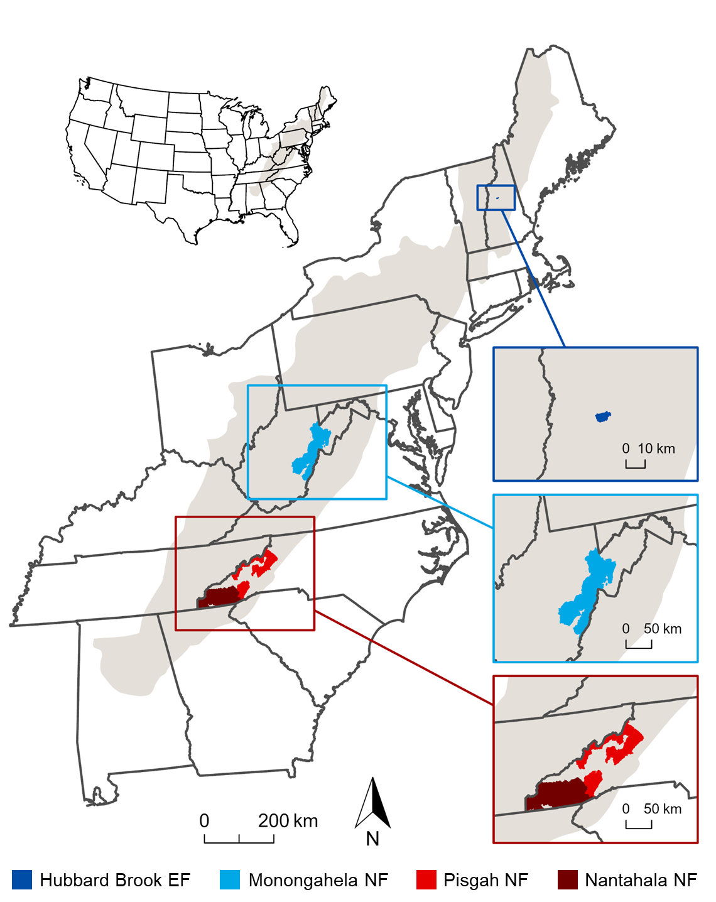

Figure 1. Location and extent of the 3 study regions in the Appalachian Mountains (shaded in gray): Hubbard Brook Experimental Forest (EF) in the White Mountains of New Hampshire (i.e., Northern Appalachians); Monongahela National Forest (NF) in the Allegheny Mountains of West Virginia (i.e., Central Appalachians); and Pisgah and Nantahala National Forests (NF) in the Blue Ridge Mountains of North Carolina (i.e., Southern Appalachians).

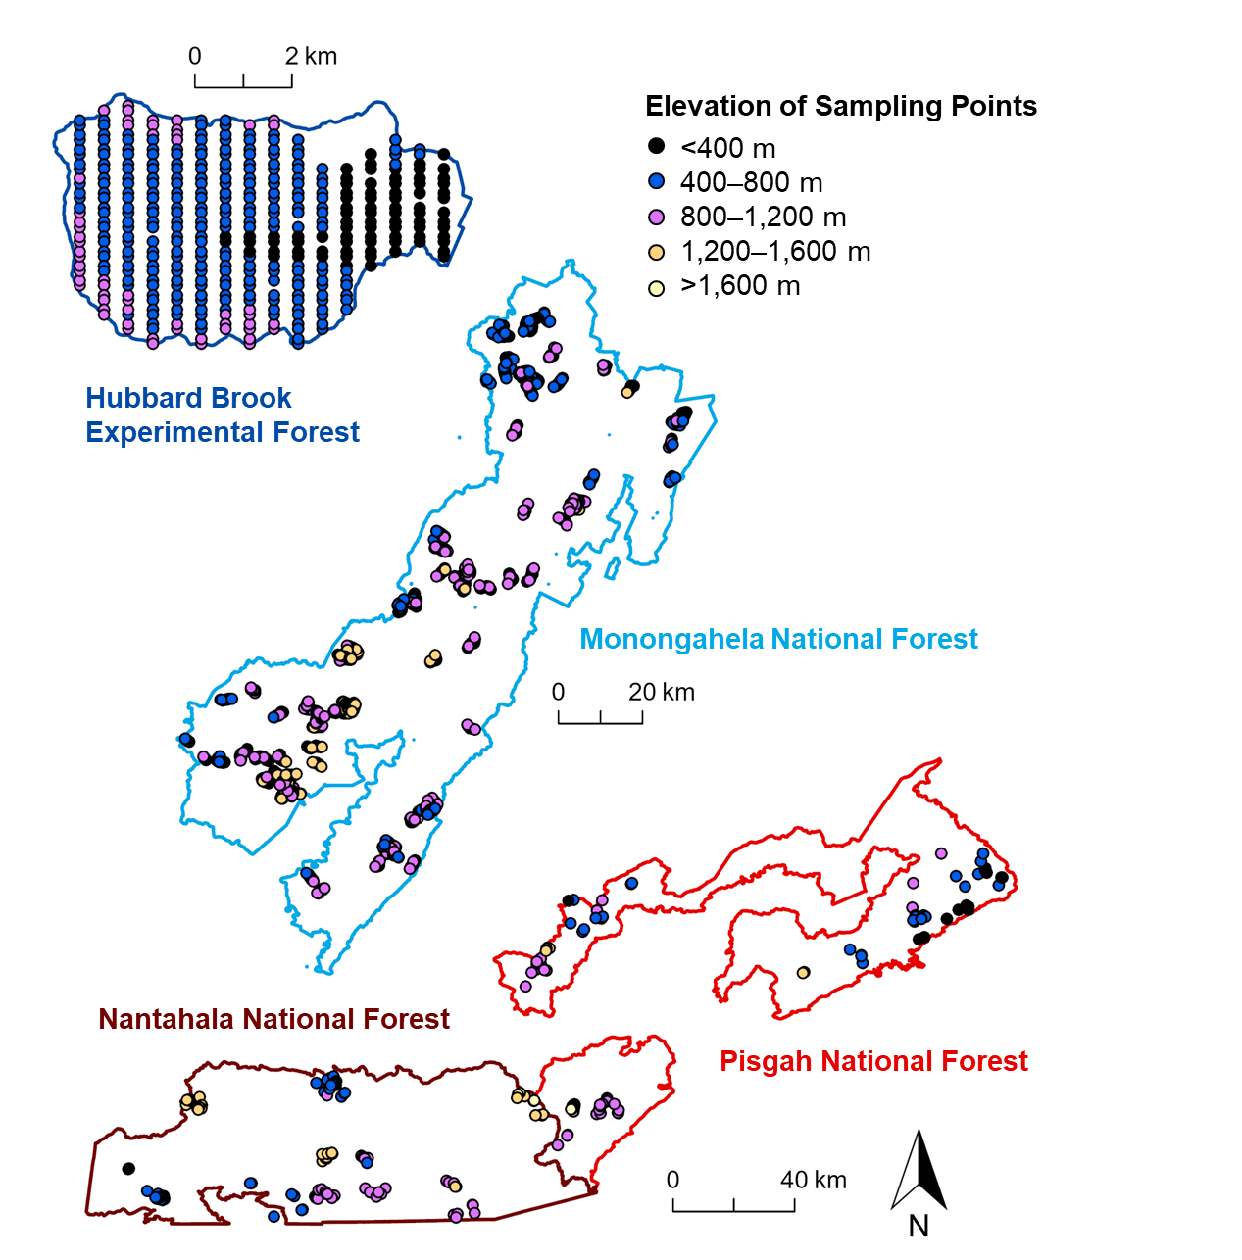

Figure 2. Locations and elevations (m) of the 373 sampling points in the Hubbard Brook Experimental Forest (i.e., Northern Appalachians study region); 1,149 sampling points in the Monongahela National Forest (i.e., Central Appalachians study region); and 211 sampling points in the Pisgah and Nantahala National Forests (i.e., Southern Appalachians study region).

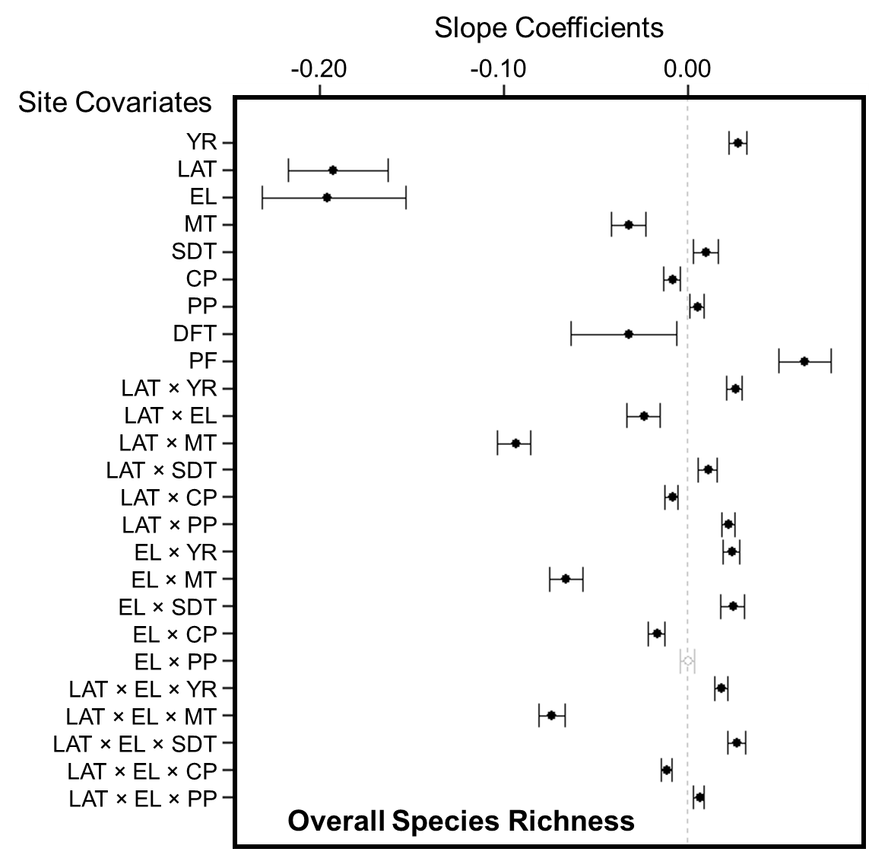

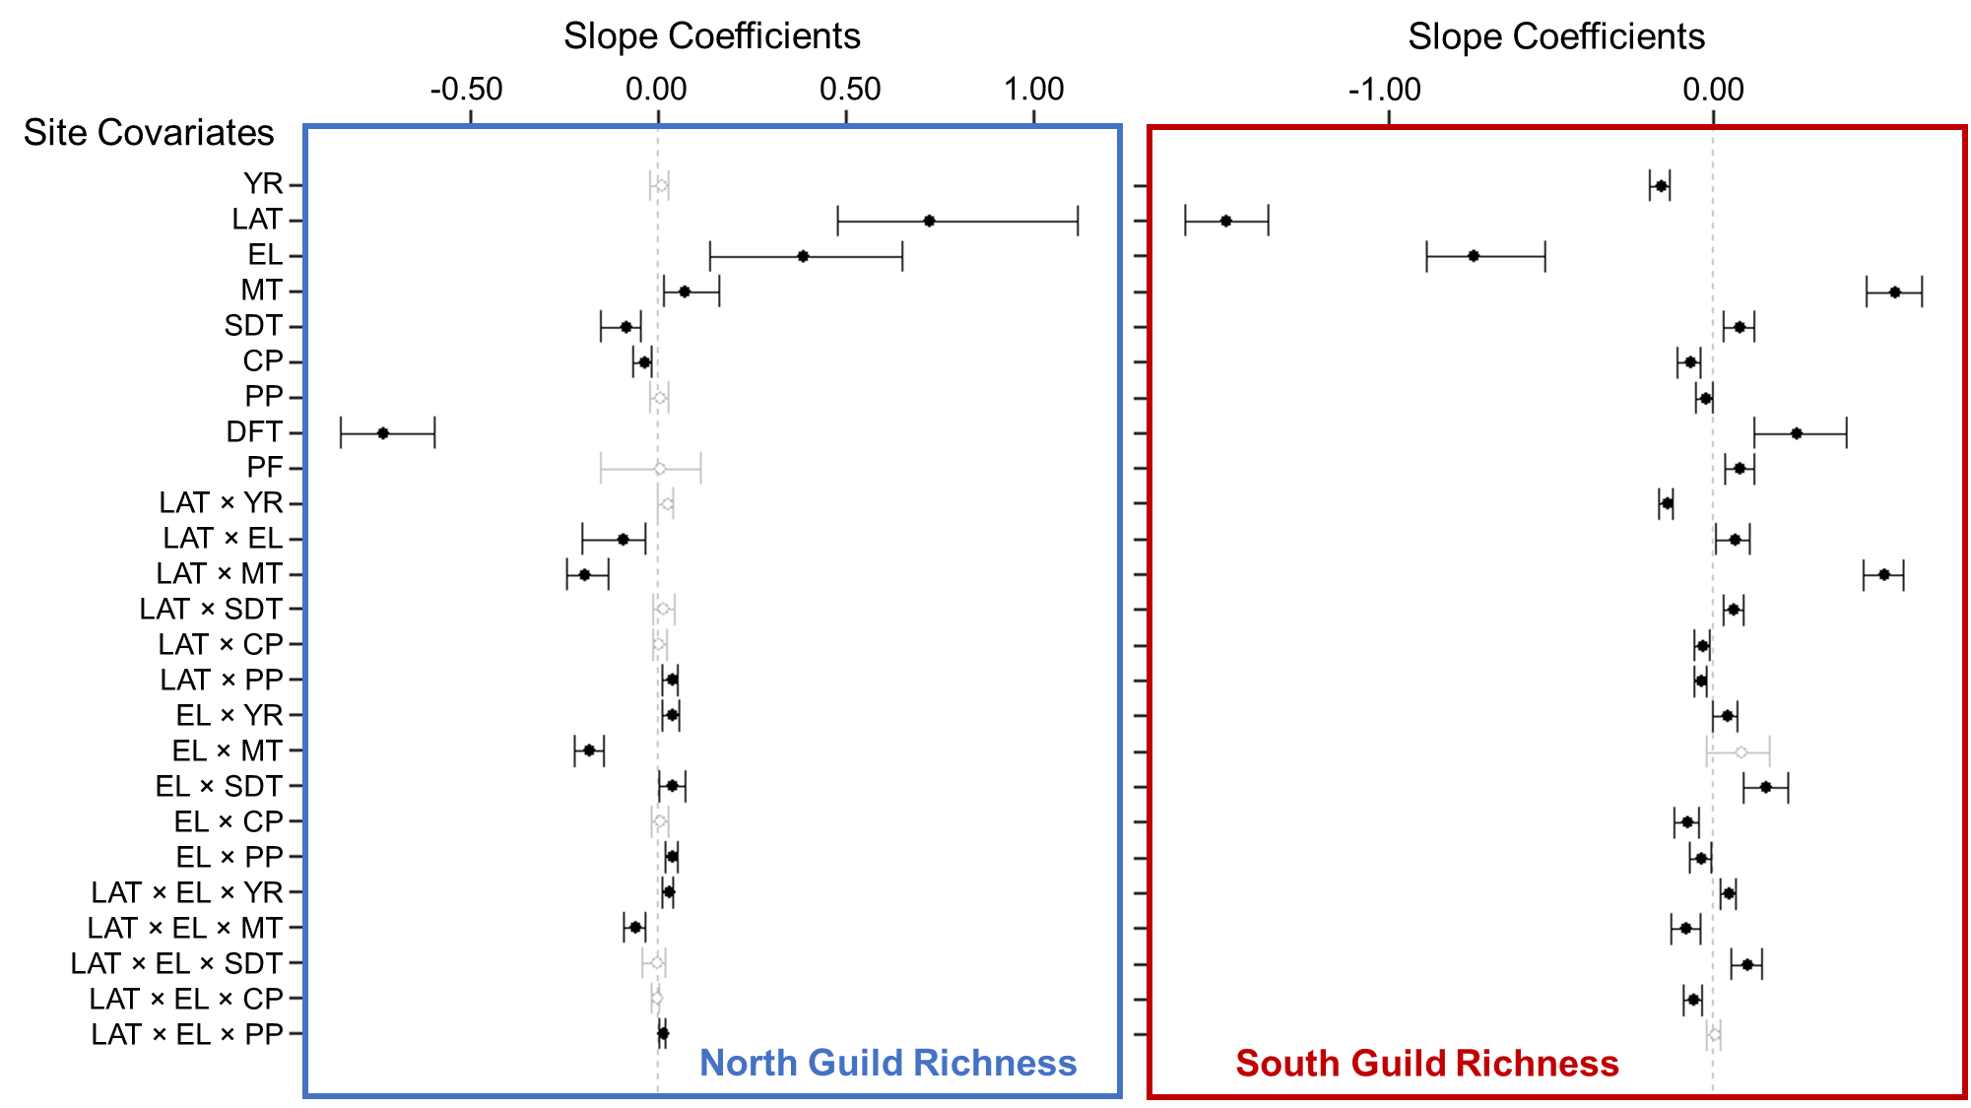

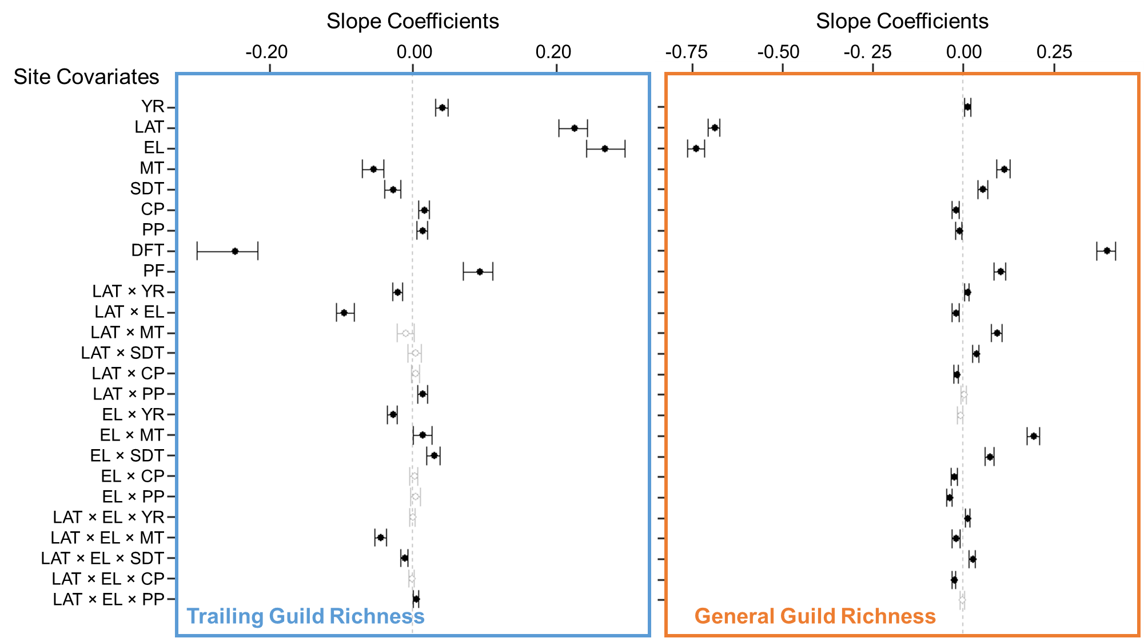

Figure 3. Whisker plots for overall species richness and guild richness (see Appendix A for guild designations and associated forest songbird species), displaying the slope coefficients of the predictor variables (i.e., site covariates), which consisted of year (YR), latitude (LAT), elevation (EL), mean breeding season (i.e., 15 May to 30 June) temperature during the year of data collection (MT), standard deviation of breeding season temperature (SDT), total breeding season precipitation during the year of data collection (CP), total breeding season precipitation during the previous year (PP), dominant forest type within 50 m as deciduous forest (DFT), and proportion of any type of forest cover within 1 km (PF). Points are located at the mean values for the posterior distributions and the corresponding whiskers encompass the 95% credible intervals. Black points with closed circles and black whiskers indicate statistical significance (i.e., credible intervals do not overlap zero).

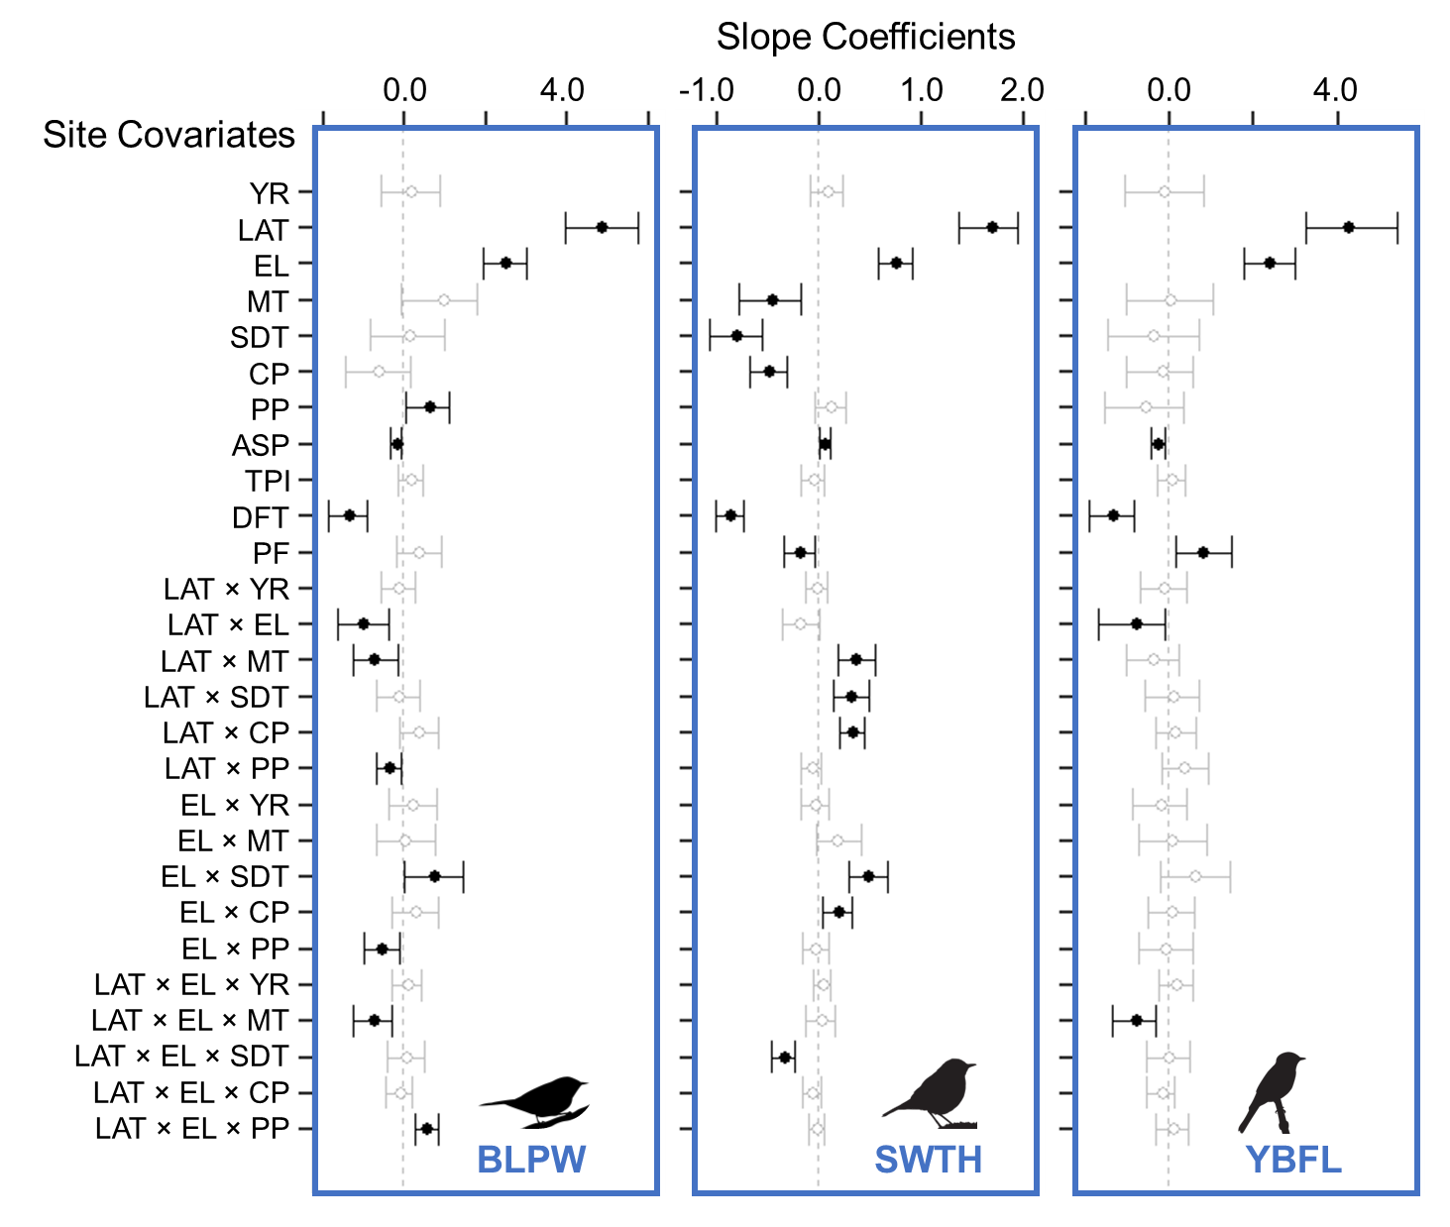

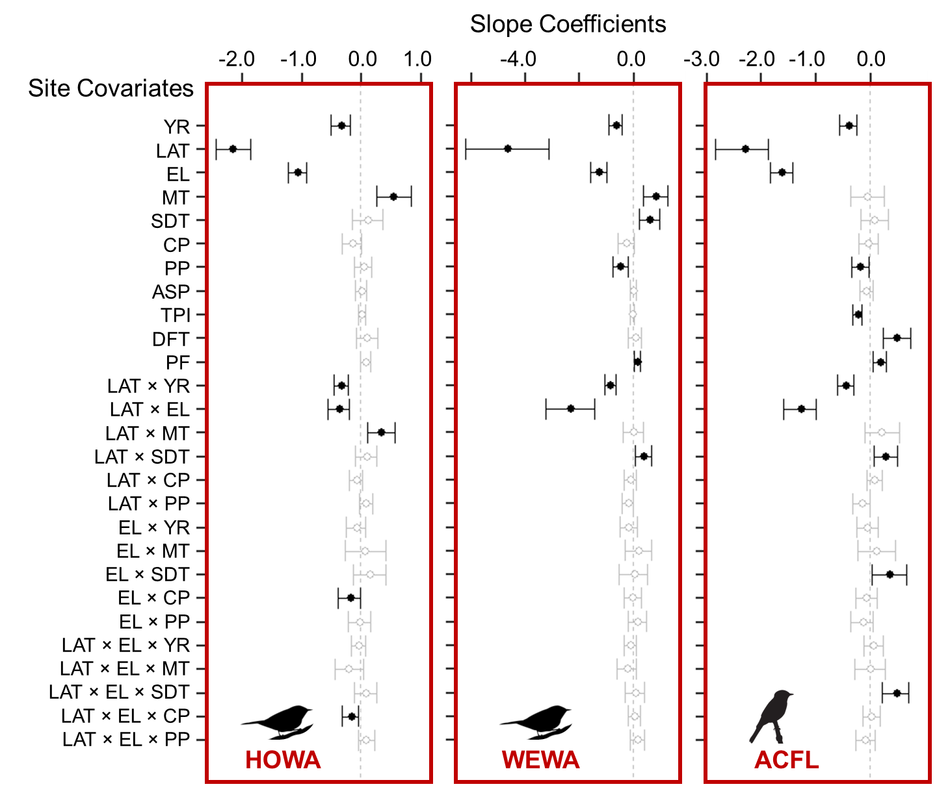

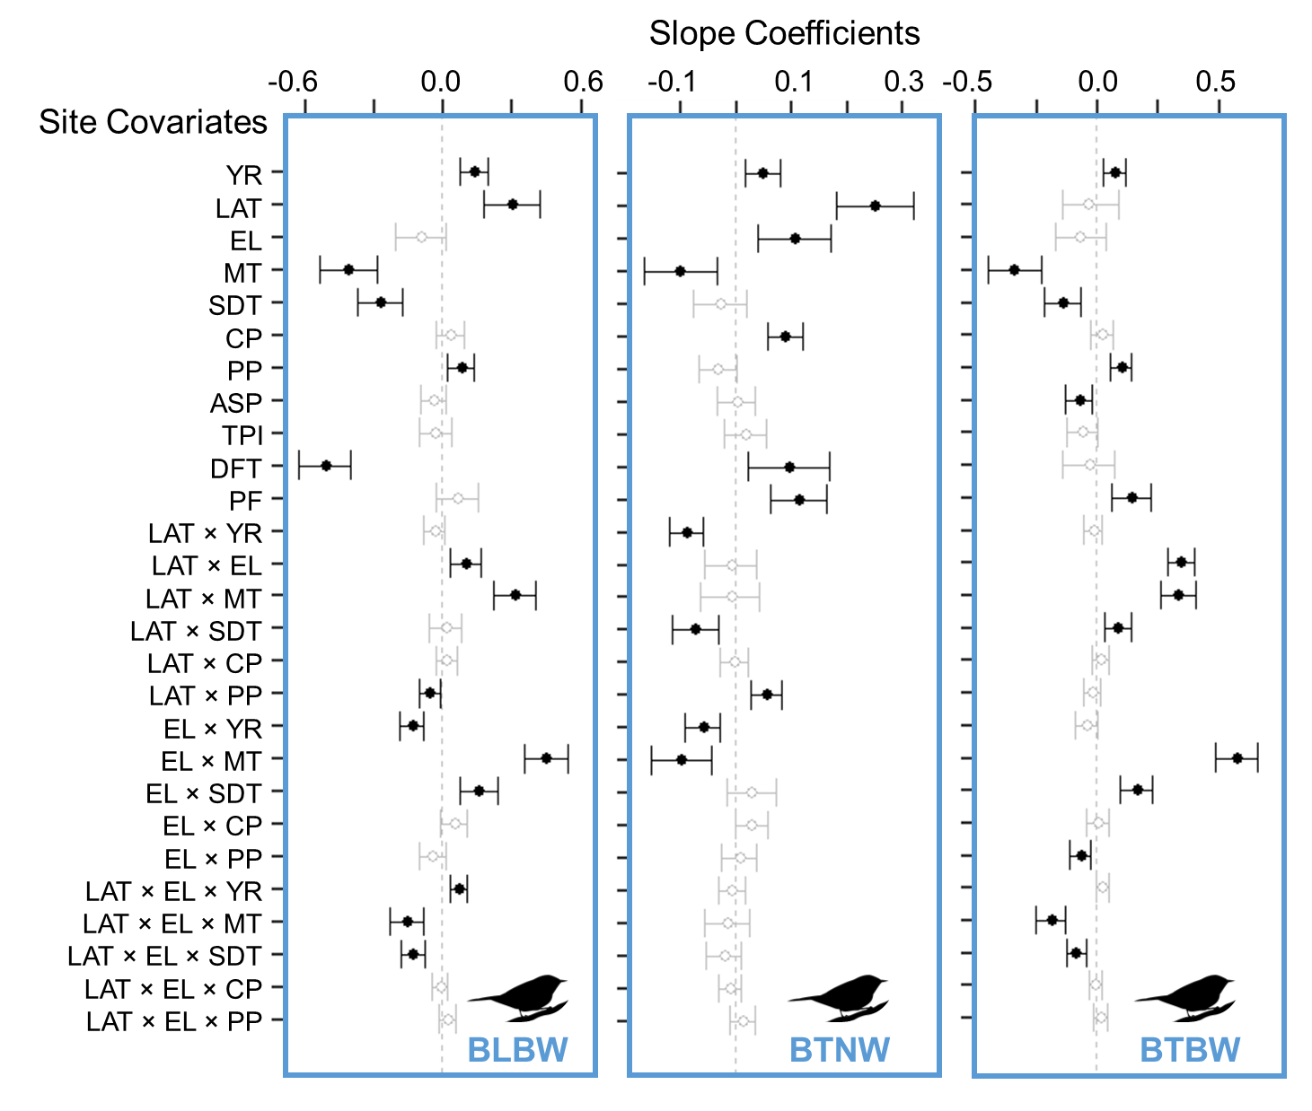

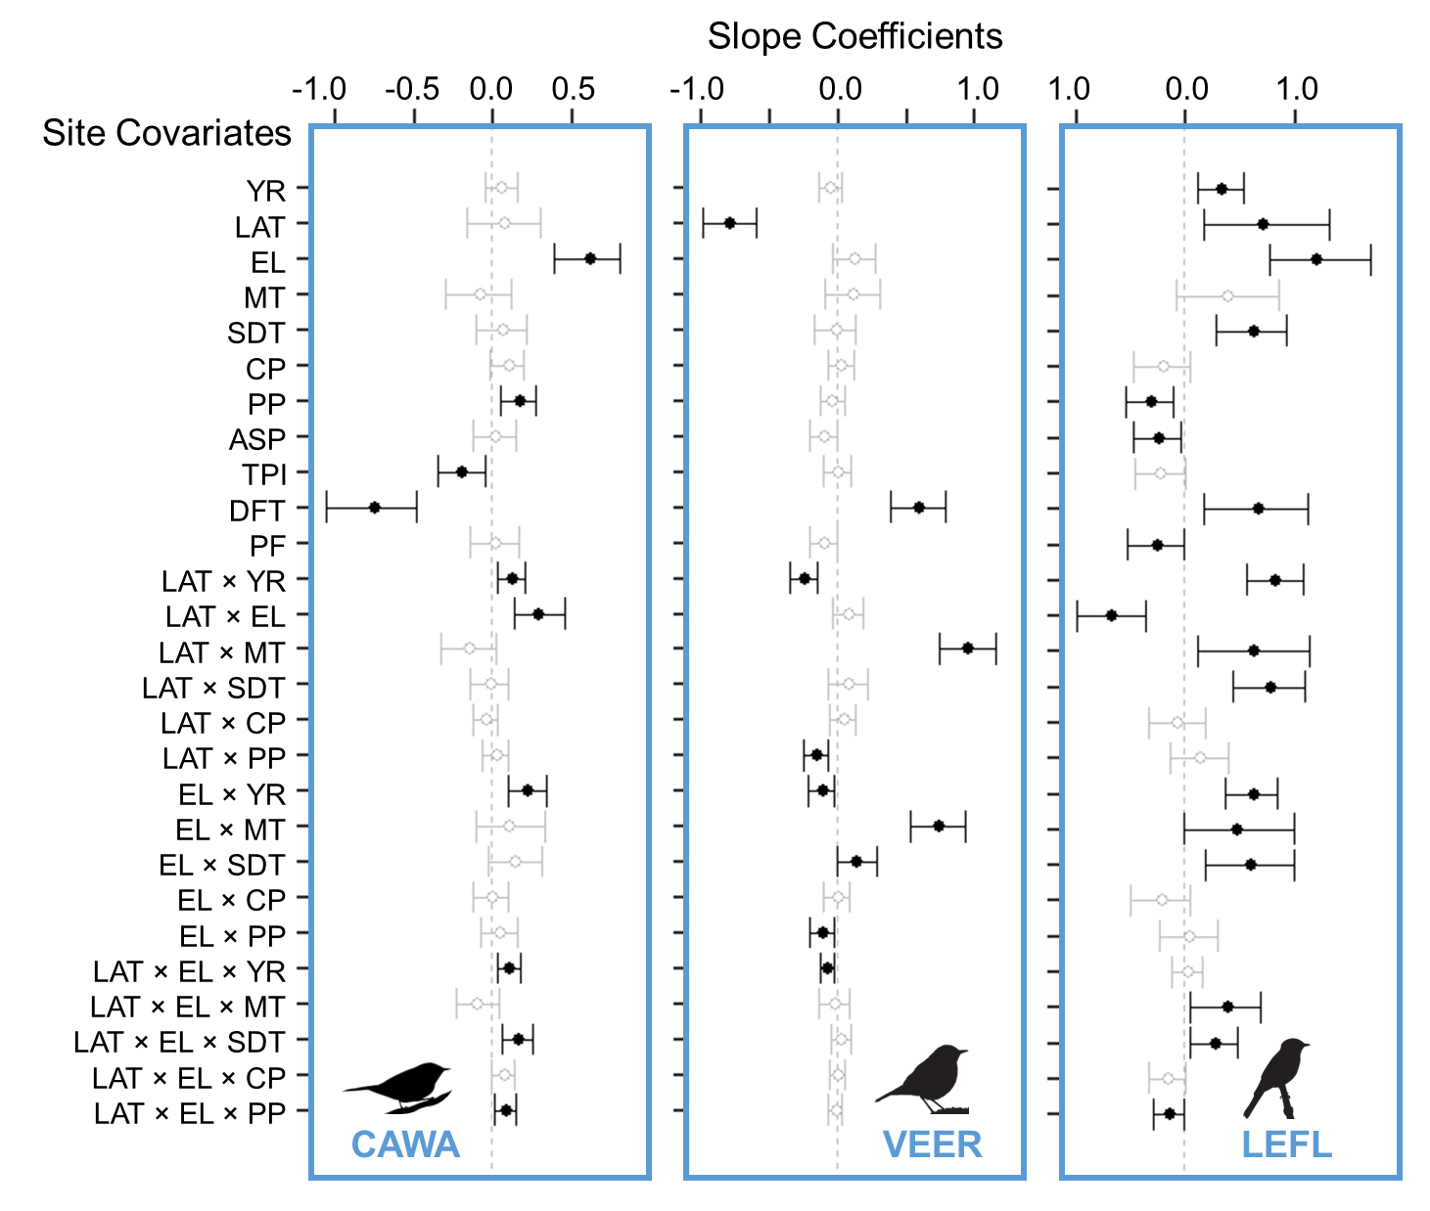

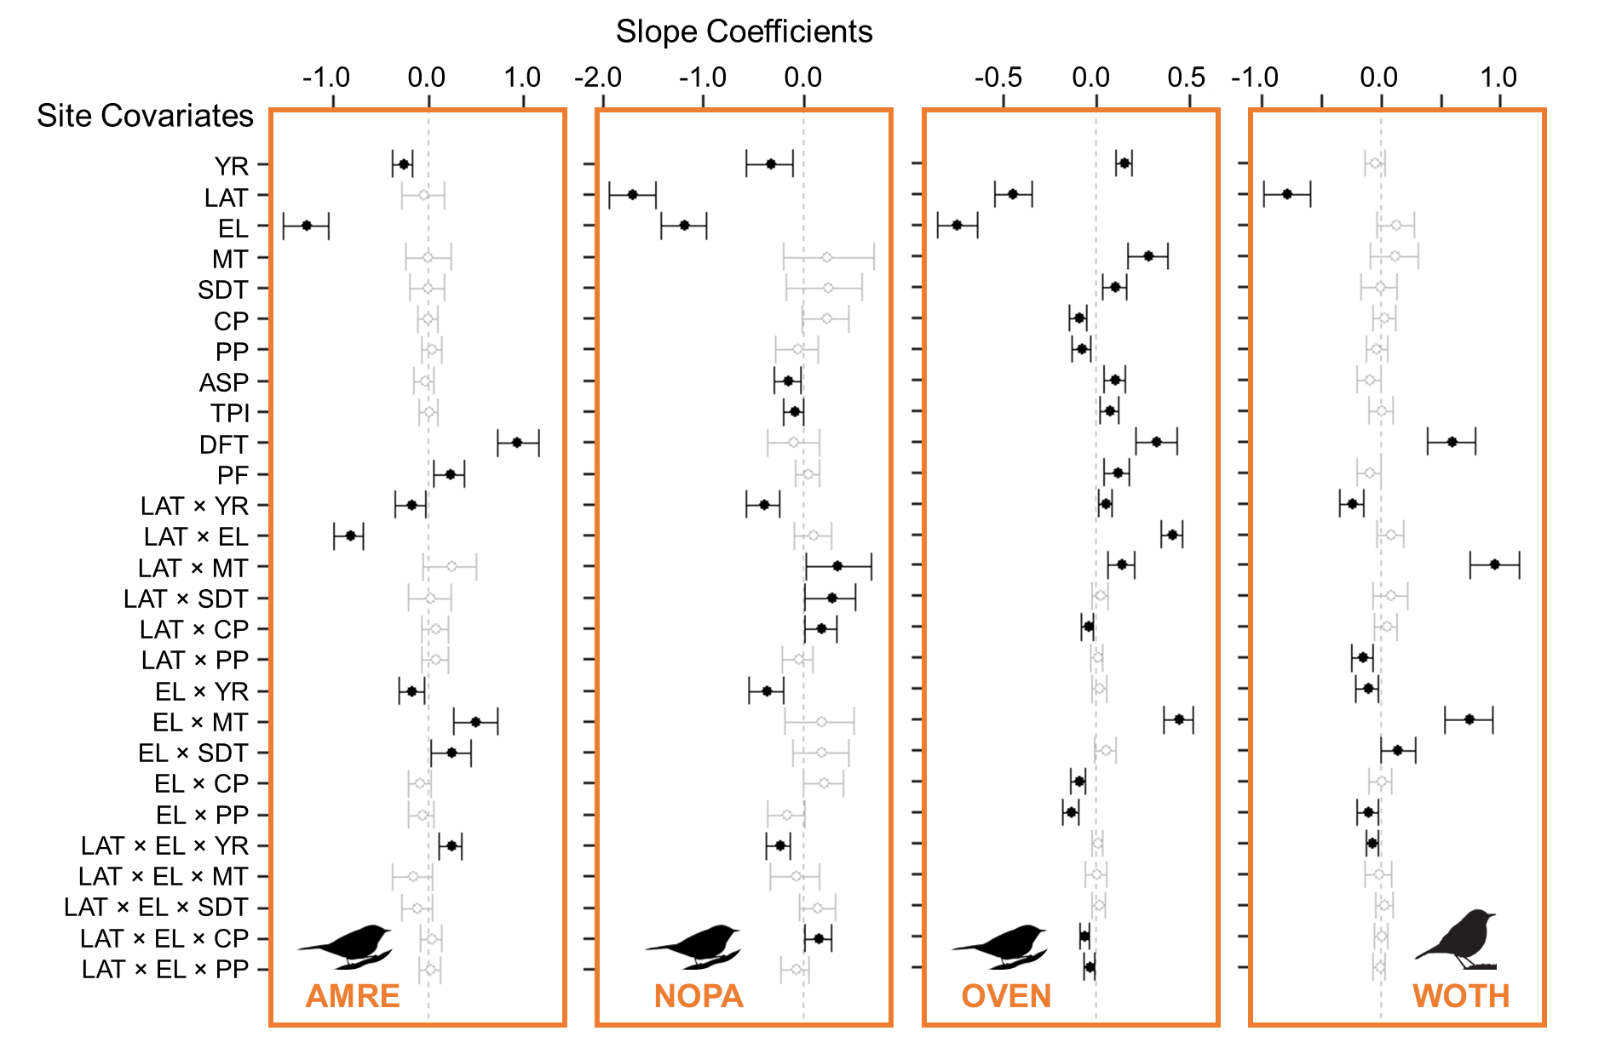

Figure 4.Whisker plots for each focal species (Table 1), displaying the slope coefficients of the predictor variables (i.e., site covariates), which consisted of year (YR), latitude (LAT), elevation (EL), mean breeding season (i.e., 15 May to 30 June) temperature during the year of data collection (MT), standard deviation of breeding season temperature (SDT), total breeding season precipitation during the year of data collection (CP), and total breeding season precipitation during the previous year (PP), aspect (ASP), topographic position index (TPI), dominant forest type within 50 m as deciduous forest (DFT), proportion of any type of forest cover within 1 km (PF),. Points are located at the mean values for the posterior distributions and the corresponding whiskers encompass the 95% credible intervals. Black points with closed circles and black whiskers indicate statistical significance (i.e., credible intervals do not overlap zero). Color of the 4-letter species code indicates its guild designation (dark blue = north guild, red = south guild, light blue = trailing guild, and orange = general guild), and the bird silhouette indicates its taxonomic family (warbler, thrush, or flycatcher).

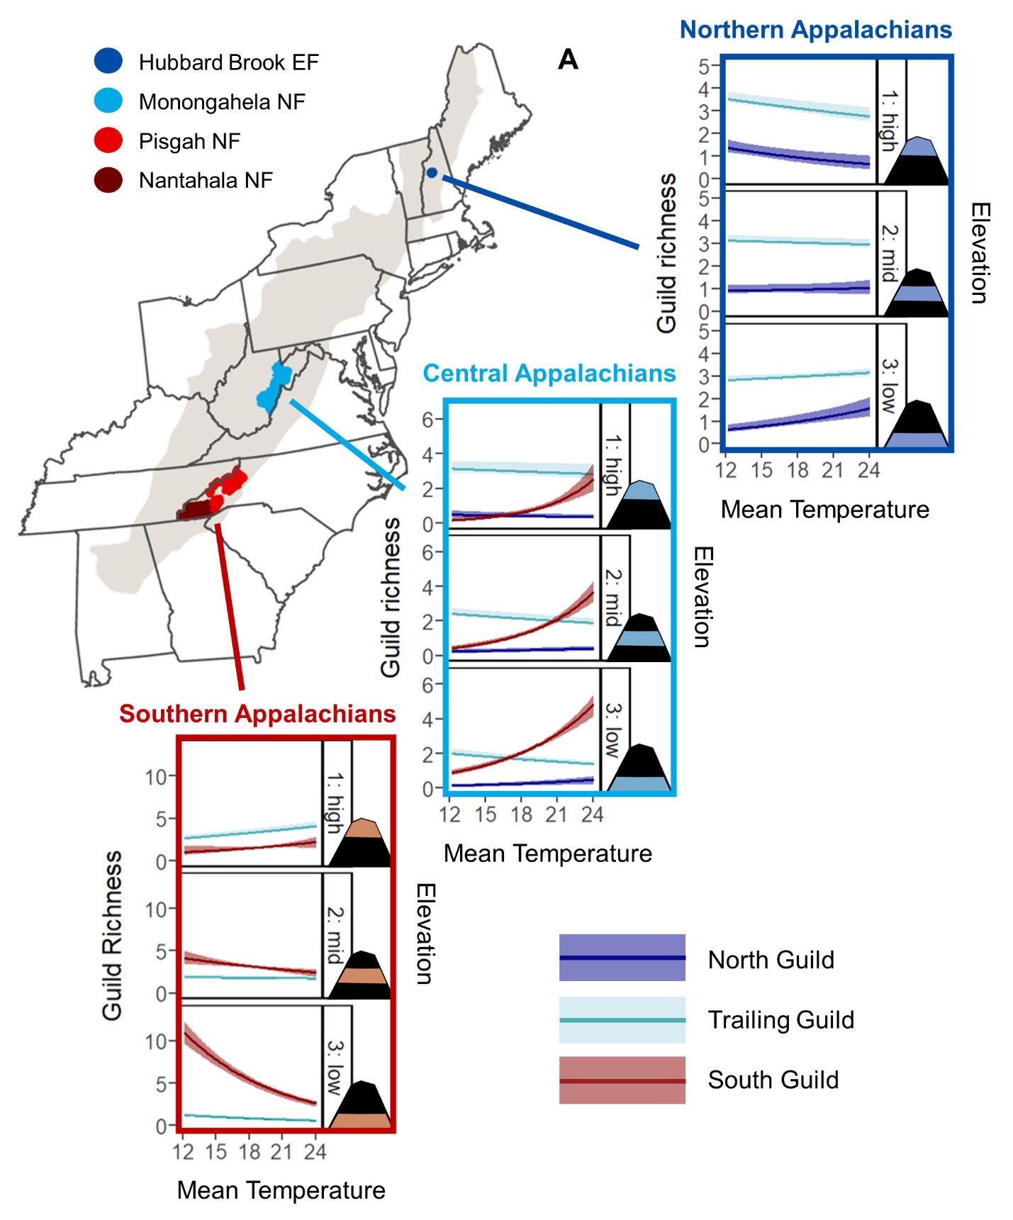

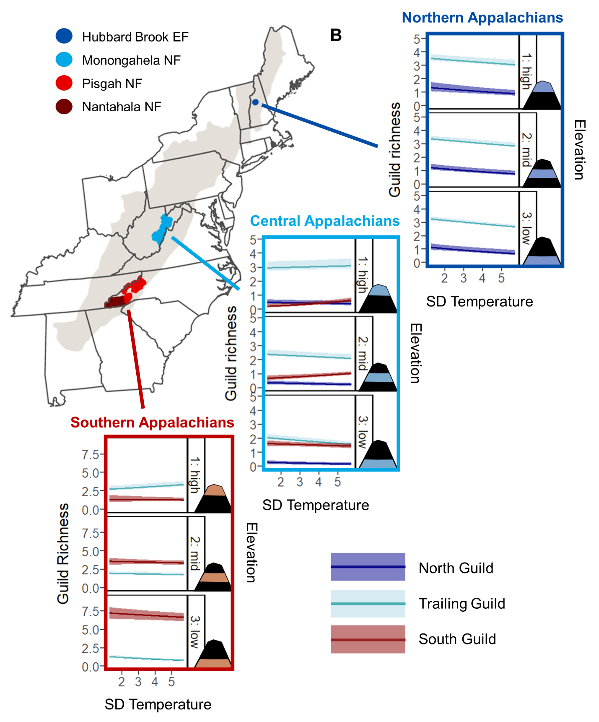

Figure 5. Relationships between (A) mean temperature (°C) or (B) SD temperature (°C) and mean expected number of species (black line) belonging to the north guild (dark blue), trailing guild (light blue), and south guild (red), with 95% credible intervals (shading), at low, mid, and high elevations in the Northern, Central, and Southern Appalachians. The low, mid, and high elevation plots correspond respectively to the 15th, 50th, and 85th percentiles of the elevation data across all sampling points within the Hubbard Brook Experimental Forest (EF) (Northern Appalachians; low = 461.4 m, mid = 609.1 m, high = 773.1 m), Monongahela National Forest (NF) (Central Appalachians; low = 706.7 m, mid = 927.3 m, high = 1226.4 m), or the 2 North Carolina National Forests (NF) (Southern Appalachians; low = 546.4 m, mid = 977.4 m, high = 1566.3 m).

**APPENDICES**

**Appendix A**

Table of the 40 forest songbird species considered in the guild richness analyses.

Table A1. List of the common name, scientific name, 4-letter species code, relative frequency, taxonomic family, and guild designation of all 40 forest songbird species considered for the guild richness analyses. Relative frequency is the number of detections across all point count surveys from all 3 study regions. The guild designation indicates the extent of the species’ range within the Appalachian Mountains, such that: species in the north guild are only found in the Northern or Central Appalachians; species in the south guild are only found in the Southern or Central Appalachians; species in the trailing guild have trailing-edge populations that are found throughout the Appalachian Mountains but are limited to higher elevations in the Southern Appalachians; and species in the general guild are found throughout the Appalachian Mountains.

|  |  |  |  |  |  |
| --- | --- | --- | --- | --- | --- |
| **Common Name**  **(*Scientific Name*)** | **Species Code** | **Relative Frequency** | **Taxonomic Family** | **Guild Designation** | **Focal Species** |
| Blackpoll warbler  (*Setophaga striata*) | BLPW | 2,220 | Parulidae | north | 1 |
| Swainson's thrush  (*Catharus ustulatus*) | SWTH | 4,465 | Turdidae | north | 1 |
| Yellow-bellied flycatcher  (*Empidonax flaviventris*) | YBFL | 1,360 | Tyrannidae | north | 1 |
| Evening grosbeak  (*Coccothraustes vespertinus*) | EVGR | 64 | Fringillidae | north | 0 |
| Hermit thrush  (*Catharus guttatus*) | HETH | 2,880 | Turdidae | north | 0 |
| Northern waterthrush  (*Parkesia noveboracensis*) | NOWA | 42 | Parulidae | north | 0 |
| Pine siskin  (*Spinus pinus*) | PISI | 125 | Fringillidae | north | 0 |
| Purple finch  (*Haemorhous purpureus*) | PUFI | 554 | Fringillidae | north | 0 |
| Ruby-crowned kinglet  (*Corthylio calendula*) | RCKI | 39 | Regulidae | north | 0 |
| Yellow-rumped warbler  (*Setophaga coronata*) | YRWA | 5,132 | Parulidae | north | 0 |
| Acadian flycatcher  (*Empidonax virescens*) | ACFL | 1,154 | Tyrannidae | south | 1 |
| Hooded warbler  (*Setophaga citrina*) | HOWA | 1,677 | Parulidae | south | 1 |
| Worm-eating warbler  (*Helmitheros vermivorum*) | WEWA | 750 | Parulidae | south | 1 |
| Cerulean warbler  (*Setophaga cerulea*) | CERW | 127 | Parulidae | south | 0 |

Table A1. Continued.

|  |  |  |  |  |  |
| --- | --- | --- | --- | --- | --- |
| **Common Name**  **(*Scientific Name*)** | **Species Code** | **Relative Frequency** | **Taxonomic Family** | **Guild Designation** | **Focal Species** |
| Kentucky warbler  (*Geothlypis formosa*) | KEWA | 42 | Parulidae | south | 0 |
| Swainson's warbler  (*Limnothlypis swainsonii*) | SWWA | 56 | Parulidae | south | 0 |
| Yellow-throated warbler  (*Setophaga dominica*) | YTWA | 93 | Parulidae | south | 0 |
| Blackburnian warbler  (*Setophaga fusca*) | BLBW | 15,776 | Parulidae | trailing | 1 |
| Black-throated blue warbler  (*Setophaga caerulescens*) | BTBW | 21,244 | Parulidae | trailing | 1 |
| Black-throated green warbler  (*Setophaga virens*) | BTNW | 21,055 | Parulidae | trailing | 1 |
| Canada warbler  (*Cardellina canadensis*) | CAWA | 1,807 | Parulidae | trailing | 1 |
| Least flycatcher  (*Empidonax minimus*) | LEFL | 288 | Tyrannidae | trailing | 1 |
| Veery  (*Catharus fuscescens*) | VEER | 1,830 | Turdidae | trailing | 1 |
| Blue-headed vireo  (*Vireo solitarius*) | BHVI | 5,691 | Vireonidae | trailing | 0 |
| Brown creeper  (*Certhia americana*) | BRCR | 2,780 | Certhiidae | trailing | 0 |
| Dark-eyed junco  (*Junco hyemalis*) | DEJU | 4,787 | Passerellidae | trailing | 0 |
| Golden-crowned kinglet  (*Regulus satrapa*) | GCKI | 4,980 | Regulidae | trailing | 0 |
| Red-breasted nuthatch  (*Sitta canadensis*) | RBNU | 2,225 | Sittidae | trailing | 0 |
| Red crossbill  (*Loxia curvirostra*) | RECR | 74 | Fringillidae | trailing | 0 |
| Winter wren  (*Troglodytes hiemalis*) | WIWR | 4,397 | Troglodytidae | trailing | 0 |
| American redstart  (*Setophaga ruticilla*) | AMRE | 1,631 | Parulidae | general | 1 |
| Northern parula  (*Setophaga americana*) | NOPA | 779 | Parulidae | general | 1 |
| Ovenbird  (*Seiurus aurocapilla*) | OVEN | 18,707 | Parulidae | general | 1 |
| Wood thrush  (*Hylocichla mustelina*) | WOTH | 1,095 | Turdidae | general | 1 |
| Black-and-white warbler  (*Mniotilta varia*) | BAWW | 2,201 | Parulidae | general | 0 |

Table A1. Continued.

|  |  |  |  |  |  |
| --- | --- | --- | --- | --- | --- |
| **Common Name**  **(*Scientific Name*)** | **Species Code** | **Relative Frequency** | **Taxonomic Family** | **Guild Designation** | **Focal Species** |
| Louisiana waterthrush  (*Parkesia motacilla*) | LOWA | 171 | Parulidae | general | 0 |
| Pine warbler  (*Setophaga pinus*) | PIWA | 249 | Parulidae | general | 0 |
| Red-eyed vireo  (*Vireo olivaceus*) | REVI | 20,618 | Vireonidae | general | 0 |
| Scarlet tanager  (*Piranga olivacea*) | SCTA | 2,798 | Cardinalidae | general | 0 |
| White-breasted nuthatch  (*Sitta carolinensis*) | WBNU | 1,194 | Sittidae | general | 0 |

**Appendix B**

JAGS model code for the guild richness analyses

model {

### PRIORS

# COMMUNITY-LEVEL MODEL PARAMETERS (JUST FOR OCCUPANCY)

community.occupancy.a ~ dlogis(0,1) #this assumes a logistic prior

community.occupancy.tau ~ dgamma(1,1)

# COMMUNITY-LEVEL PARAMETERS FOR SITE COVARIATE SLOPE COEFFICIENTS

for (sitecov in 1:n.sitecovs) {

mu.alpha[sitecov] ~ dnorm(0, 0.1)

tau.alpha[sitecov] ~ dgamma(1,1)

}

# COMMUNITY-LEVEL PARAMETERS FOR DETECTION COVARIATE SLOPE COEFFICIENTS

for (detcov in 1:n.detcovs) {

mu.beta[detcov] ~ dnorm(0, 0.1)

tau.beta[detcov] ~ dgamma(1,1)

}

# SPECIES-SPECIFIC PRIORS FROM THE COMMUNITY-LEVEL PRIOR DISTRIBUTIONS

for (species in 1:n.species) {

# INTERCEPTS

alpha0[species] ~ dnorm(community.occupancy.a, community.occupancy.tau)

beta0[species] ~ dnorm(0, 0.1)

# SLOPE COEFFICIENTS FOR SITE COVARIATES

for (sitecov in 1:n.sitecovs) {

alpha[species, sitecov] ~ dnorm(mu.alpha[sitecov], tau.alpha[sitecov])

}

# SLOPE COEFFICIENTS FOR DETECTION COVARIATES

for (detcov in 1:n.detcovs) {

beta[species, detcov] ~ dnorm(mu.beta[detcov], tau.beta[detcov])

}

}

# NOTES: Loop over all species.

# PARAMETERS FOR IMPUTATION OF DETECTION COVARIATES

for (region in 1:n.regions) {

# TIME

time.mu[region] ~ dnorm(0, 1) #NOTE: Normal distribution

time.tau[region] ~ dgamma(1, 1)

# WIND CODE

wind.prob[region] ~ dbeta(1, 1)

# SKY CODE

sky.prob[region] ~ dbeta(1, 1)

}

# NOTES: Loop over each study region.

### LIKELIHOOD

# IMPUTATION OF DETECTION COVARIATES

for (site in 1:n.sites){

for (year in 1:n.years[site]) {

for (replicate in 1:n.replicates[site, year]) {

time[site, year, replicate] ~ dnorm(time.mu[region[site]],

time.tau[region[site]])

wind[site, year, replicate] ~ dbern(wind.prob[region[site]])

sky[site, year, replicate] ~ dbern(sky.prob[region[site]])

}

}

}

# NOTES: Loop over sites, years, and replicates.

for (species in 1:n.species) {

# Loop to estimate the Z matrix (true site occurrence) for each species at

# each site

for (site in 1:n.sites){

for (year in 1:n.years[site]) {

# OCCUPANCY MODEL

logit(psi[site, year, species]) <- alpha0[species] +

inprod(alpha[species, 1:n.sitecovs],

sitecov.array[site, year, 1:n.sitecovs])

# ESTIMATING OCCUPANCY

Z[site, year, species] ~ dbern(psi[site, year, species])

# Loop to estimate detection each species at each site during each

# sampling replicate

for (replicate in 1:n.replicates[site, year]) {

# DETECTION MODEL

logit(p[site, year, replicate, species]) <- beta0[species] +

beta[species, 1] * day[site, year, replicate] +

beta[species, 2] * time[site, year, replicate] +

beta[species, 3] * wind[site, year, replicate] +

beta[species, 4] * sky[site, year, replicate]

# MODEL PROBABILITY OF DETECTION FOR 1 MINUTE

p.adjusted[site, year, replicate, species] <- 1 - (1 –

p[site, year, replicate, species]) ^ exponent.array[site,

year, replicate]

# ESTIMATING PROBABILITY OF DETECTION

mu.p[site, year, replicate, species] <- p.adjusted[site, year,

replicate, species] * Z[site, year, species]

Y[site, year, replicate, species] ~ dbern(mu.p[site, year,

replicate, species])

}

# NOTES: Loop over each replicate for each site (variable number of

# replicates depending on site and year).

} #end year loop

} #end site loop

} #end species loop

### DERIVED QUANTITIES

# Loop to determine site-level richness estimates for the whole community and # for subsets or assemblages of interest per year

for (site in 1:n.sites) {

for (year in 1:n.years[site]) {

site.species.richness[site, year] <- sum(Z[site, year, 1:n.species])

north.guild.richness[site, year] <- inprod(Z[site, year, 1:n.species],

north.guild[1:n.species])

south.guild.richness[site, year] <- inprod(Z[site, year, 1:n.species],

south.guild[1:n.species])

trailing.guild.richness[site, year] <- inprod(Z[site, year,

1:n.species], trailing.guild[1:n.species])

general.guild.richness[site, year] <- inprod(Z[site, year,

1:n.species], general.guild[1:n.species])

}

}

}

**Appendix C**

JAGS model code for the focal species analyses

model {

### PRIORS

for (species in 1:n.species) {

# INTERCEPTS

alpha0[species] ~ dnorm(0, 0.01) #intercept for abundance model

#(site covariates)

beta0[species] ~ dnorm(0, 0.01) #intercept for detection model

#(detection covariates)

# RANDOM SITE EFFECT

tau.rse[species] ~ dgamma(0.01, 0.01) #for random site effects

for (site in 1:n.sites){

random.site.effect[species, site] ~ dnorm(alpha0[species],

tau.rse[species]) #for random site effects

}

# NOTES: Loop over the number of unique sites

# SLOPE COEFFICIENTS FOR SITE COVARIATES

for (alpha.index in 1:n.alphas) {

alpha[species, alpha.index] ~ dnorm(0, 0.01)

#create a slope coefficient for each site covariate in the abundance

#model

}

# SLOPE COEFFICIENTS FOR DETECTION COVARIATES

for (detcov in 1:n.detcovs) {

beta[species, detcov] ~ dnorm(0, 0.01)

#create a slope coefficient for each detection covariate in the

#detection model

}

}

# NOTES: Loop over each focal species.

# PARAMETERS FOR IMPUTATION OF DETECTION COVARIATES

for (region in 1:n.regions) {

# TIME

time.mu[region] ~ dnorm(0, 0.01)

time.tau[region] ~ dgamma(0.1, 0.1)

# NOTE: Normal distribution.

# WIND CODE

wind.prob[region] ~ dbeta(1, 1)

# SKY CODE

sky.prob[region] ~ dbeta(1, 1)

}

# NOTES: Loop over each study region.

### LIKELIHOOD

# IMPUTATION OF DETECTION COVARIATES

for (site in 1:n.sites){

for (year in 1:n.years[site]) {

for (visit in 1:n.visits[site,year]) {

time[site, year, visit] ~ dnorm(time.mu[region[site]],

time.tau[region[site]])

wind[site, year, visit] ~ dbern(wind.prob[region[site]])

sky[site, year, visit] ~ dbern(sky.prob[region[site]])

}

}

}

# NOTES: Loop over sites, years, and visits.

# ESTIMATE ABUNDANCE AND DETECTION PROBABILITY

for (species in 1:n.species) {

# Loop to estimate N (true abundance) for each species at each site

for (site in 1:n.sites) {

for (year in 1:n.years[site]) {

# ABUNDANCE MODEL

log(lambda[site, year, species]) <- alpha[species, 1] *

sitecov.array[site, year, 1] + #year

alpha[species, 2] * sitecov.array[site, year, 2] + #elevation

alpha[species, 3] * sitecov.array[site, year, 3] + #aspect

alpha[species, 4] * sitecov.array[site, year, 4] + #TPI

alpha[species, 5] * sitecov.array[site, year, 5] +

#dominant forest type == Deciduous

alpha[species, 6] * sitecov.array[site, year, 6] +

#proportion of forest within 1 km

alpha[species, 7] * sitecov.array[site, year, 7] +

#mean current temperature

alpha[species, 8] * sitecov.array[site, year, 8] +

#SD temperature

alpha[species, 9] * sitecov.array[site, year, 9] +

#total current precip

alpha[species, 10] * sitecov.array[site, year, 10] +

#total previous precip

alpha[species, 11] * sitecov.array[site, year, 2] *

sitecov.array[site, year, 1] + #elevation x year

alpha[species, 12] * sitecov.array[site, year, 2] *

sitecov.array[site, year, 7] +

#elevation x mean current temperature

alpha[species, 13] * sitecov.array[site, year, 2] *

sitecov.array[site, year, 8] + #elevation x SD temperature

alpha[species, 14] * sitecov.array[site, year, 2] *

sitecov.array[site, year, 9] +

#elevation x total current precip

alpha[species, 15] * sitecov.array[site, year, 2] *

sitecov.array[site, year, 10] +

#elevation x total previous precip

alpha[species, 16] * sitecov.array[site, year, 7] *

sitecov.array[site, year, 1] +

#mean current temperature x year

alpha[species, 17] * sitecov.array[site, year, 7] *

sitecov.array[site, year, 8] +

#mean current temperature x SD temperature

alpha[species, 18] * sitecov.array[site, year, 7] *

sitecov.array[site, year, 9] +

#mean current temperature x total current precip

alpha[species, 19] * sitecov.array[site, year, 7] *

sitecov.array[site, year, 10] +

#mean current temperature x total previous precip

alpha[species, 20] * sitecov.array[site, year, 2] *

sitecov.array[site, year, 7] * sitecov.array[site, year, 1] + #elevation x mean current temperature x year

alpha[species, 21] * sitecov.array[site, year, 2] *

sitecov.array[site, year, 7] * sitecov.array[site, year, 8] + #elevation x mean current temperature x SD temperature

alpha[species, 22] * sitecov.array[site, year, 2] *

sitecov.array[site, year, 7] * sitecov.array[site, year, 9] + #elevation x mean current temperature x total current precip

alpha[species, 23] * sitecov.array[site, year, 2] *

sitecov.array[site, year, 7] * sitecov.array[site, year, 10] + #elevation x mean current temperature x total previous precip

random.site.effect[species, site] #random site effect

# ESTIMATING ABUNDANCE

N[site, year, species] ~ dpois(lambda[site, year, species])

for (visit in 1:n.visits[site,year]) {

# OBSERVATION PROBABILITY

Y[site, year, visit, 1, species] ~ dbin(p.adjusted[site, year,

visit, 1, species], N[site, year, species])

z[site, year, visit, 1, species] <- N[site, year, species] –

Y[site, year, visit, 1, species]

for (i in 2:3) {

Y[site, year, visit, i, species] ~ dbin(p.adjusted[site, year,

visit, i, species], z[site, year, visit, i-1, species])

z[site, year, visit, i, species] <- N[site, year, species] –

sum(Y[site, year, visit, 1:i, species])

}

# Loop to estimate detection each species at each site during

# each sampling replicate

for (replicate in 1:3) {

# DETECTION MODEL

logit(p[site, year, visit, replicate, species]) <-

beta0[species] + beta[species, 1] * day[site, year, visit] + beta[species, 2] * time[site, year, visit] +

beta[species, 3] * wind[site, year, visit] +

beta[species, 4] * sky[site, year, visit]

# MODEL PROBABILITY OF DETECTION FOR 1 MINUTE

p.adjusted[site, year, visit, replicate, species] <- 1 - (1 –

p[site, year, visit, replicate, species]) ^ exponent.array[site, year, visit, replicate]

}

# NOTES: Loop over each replicate for each site (variable number

# of replicates depending on site and year).

} # end visit loop

} #end year loop

} # end site loop

} # end site loop

}

**Appendix D**

Table of model information for overall species richness, the 4 guild designations, and the 16 focal forest songbird species considered in the guild richness and focal species analyses.

Table D1. List of the 4 guild designations and 16 focal forest songbird species (sorted by guild and family), with corresponding model information that includes the number of chains (Chains), total iterations (Total), burn-in (Burn), thinning rate (Thin), and resulting posterior iterations (Posterior).

|  |  |  |  |  |  |  |  |
| --- | --- | --- | --- | --- | --- | --- | --- |
| **Guild** | **Family** | **Species** | **Chains** | **Total** | **Burn-In** | **Thin** | **Posterior** |
| ALL |  |  | 3 | 3,500 | 2,500 | 1 | 3,000 |
| NORTH | |  | 3 | 3,500 | 2,500 | 1 | 3,000 |
|  | Parulidae | BLPW | 3 | 153,000 | 123,000 | 3 | 30,000 |
|  | Turdidae | SWTH | 3 | 51,000 | 39,000 | 3 | 12,000 |
|  | Tyrannidae | YBFL | 3 | 167,000 | 137,000 | 3 | 30,000 |
| SOUTH | |  | 3 | 3,500 | 2,500 | 1 | 3,000 |
|  | Parulidae | HOWA | 3 | 56,000 | 50,000 | 3 | 6,000 |
|  | Parulidae | WEWA | 3 | 67000 | 49000 | 3 | 18000 |
|  | Tyrannidae | ACFL | 3 | 54,000 | 45,000 | 3 | 9,000 |
| TRAILING | |  | 3 | 3,500 | 2,500 | 1 | 3,000 |
|  | Parulidae | BLBW | 3 | 11,000 | 2,000 | 3 | 9,000 |
|  | Parulidae | BTNW | 3 | 11,000 | 2,000 | 3 | 9,000 |
|  | Parulidae | BTBW | 3 | 11,000 | 2,000 | 3 | 9,000 |
|  | Parulidae | CAWA | 3 | 26,000 | 20,000 | 3 | 6,000 |
|  | Turdidae | VEER | 3 | 19,000 | 10,000 | 3 | 9,000 |
|  | Tyrannidae | LEFL | 3 | 29,000 | 20,000 | 3 | 9,000 |
| GENERAL | |  | 3 | 3,500 | 2,500 | 1 | 3,000 |
|  | Parulidae | AMRE | 3 | 29,000 | 20,000 | 3 | 9,000 |
|  | Parulidae | NOPA | 3 | 73,000 | 64,000 | 3 | 9,000 |
|  | Parulidae | OVEN | 3 | 11,000 | 2,000 | 3 | 9,000 |
|  | Turdidae | WOTH | 3 | 36,000 | 30,000 | 3 | 6,000 |